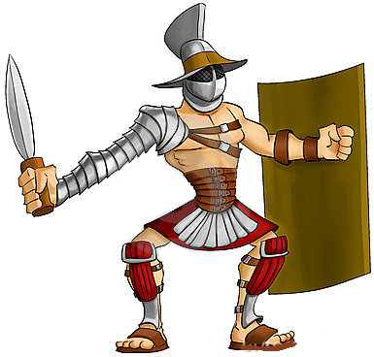
A gladiator called Spartacus
Spartacus was a man from a land called Thrace and was a member of the Roman army but one day he decided to run away from the army without permission. In the Roman Empire, this was breaking the law and he was soon arrested and sold into slavery.
He was bought and taught how to be a gladiator in a ludus in a land called Capua. However, Spartacus didn’t like being a gladiator and decided he wanted to escape. He and a lot of other slaves and gladiators escaped the ludus and hid on a mountain. Lots of other slaves from all around escaped and came to live with Spartacus on his mountain. The slaves seen Spartacus as a hero whilst Romans seen him as a villain.
The people of Rome were not happy with their slaves escaping so they asked the army to go and capture them all. However, Spartacus now had almost 100,000 slaves who all wanted to be free and they decided they wanted to leave Rome and escape to a land called Gaul. The Romans didn’t want this to happen because Spartacus could be dangerous in the future.
The army tried to stop Spartacus and his friend’s lots of times but Spartacus was too strong. At last, Spartacus fell into a trap set up by a rich and powerful Roman general. Lots of slaves were captured and some escaped. However, nobody truly knows what happened to Spartacus whether he escaped or was captured.

Questions
1- Do you think Spartacus was a hero or a villain? Explain why.
___________________________________________________________________________

2- Do you think Spartacus escaped or was captured? Explain why.
___________________________________________________________________________

3- Do you think Spartacus should have been arrested or not? Explain why.
___________________________________________________________________________

4- Do you think Romans should have been allowed to have slaves? Explain why.
___________________________________________________________________________

5- What is a ludus?
___________________________________________________________________________

