Ancient Menu Making: Recipes

- Roasted Wood Pidgeon with Honey and Corriander

- Barley Porridge

- Stuffed Kidneys

- Chicken Meatballs

- Barley and Vegetable Soup
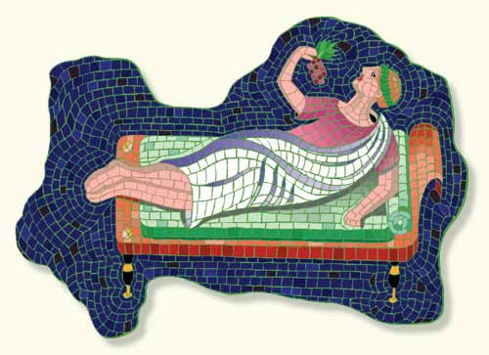
- Baked Ham in Pastry with Figs

- Roast Chicken in Honey

- Roast Peacock

- Spicy Mushy Peas

- Lobster

- Almond and Semolina Pudding

- Stuffed Mackerel

- Deep Fried Honey Fritters

- Pork and Apricot

- Melon with Mint Dressing

