The verb to be (present tense)
As in most languages, this is irregular, but will quickly become familiar:
Singular:
εἰμι I am
εἰ you (sg) are
ἐστι(ν) he/she/it
Plural:
ἐσμεν we are
ἐστε you (are) are
εἰσι(ν) they are
Translate into Greek:
1 I am not Actaeon. _______________________________________
2 You (sg) are not a god. _______________________________________
3 I am a man not a deer. _______________________________________
4 You (sg) are Artemis. _______________________________________
5 We are gods. _______________________________________
For deer - ἔλαϕος
The fact file of Artemis -
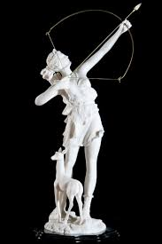
- Goddess of hunting, nature, archery, wild animals, young women and the moon.
-Her symbol is the bow and arrow.
-Her sacred animals are the deer, the snake and the hound. Two of these animals are present in the story of Artemis and Actaeon.
-Her sacred plants are the palm tree, and cypress.
-The places considered sacred by her are Delos (site of her birth), Arcadia (site of her hunting grounds), and the city of Ephesus – one of the seven wonder of the ancient world.

