Barracks Fact Sheet
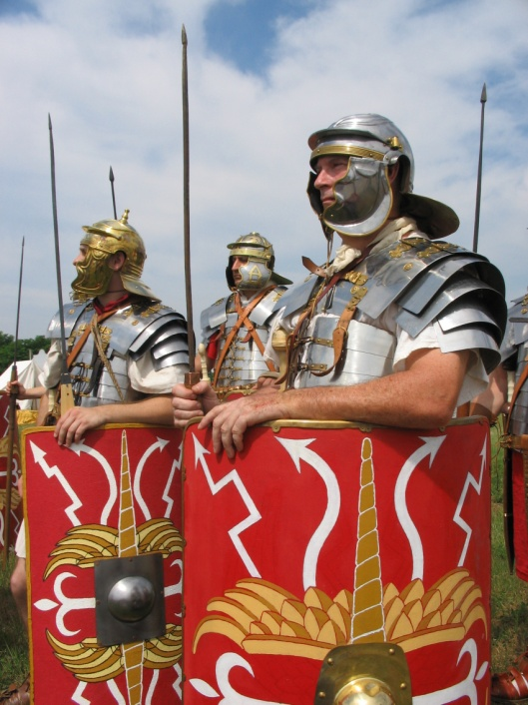
The Romans In Britain
Why the Romans came to Britain.
They wanted more land for the Empire.
They wanted to trade with the British Tribes.
There were a lot of wealth and resources in Britain.
It was a source of fame for the Emperor or General.
Who did they meet in Britain?
Celtic tribes – some were friendly, some fought against the Romans.
The Romans fought their way across Britain until they control everything from Hadrian’s Wall to Cornwall.
Life in Barracks
Barracks as permanent settlement
The barracks were similar to legionary camp; the rooms in the Barracks would be how the legion formed up in tents.
Purpose of the Barracks
Control of area – The Romans chose this position to keep control of the dangerous Silures tribe
Officers and legionaries in the barracks.
There 80 men per century, plus a Centurion, an Optio, a Signaller and a Standard Bearer.
Each century had its own barrack block.
Officers had the largest rooms in the barracks to themselves. The rest of the men would live in rooms of eight men.
Diet and daily life
Standard army diet was beans, grains and meat of some form.
Beans would be made into a stew or casserole, The meat was normally salted or dried to stop it from going rotten.
No women were allowed in the Barracks.
Many people, such as traders, followed the army to sell to the legionaries.
Life in the army
Who’s in a Legion
Legions contained 5000 men
There were 10 Cohorts per Legion
There were 6 Centuries per Cohort
There were 80 men per century
Each legion also had an attachment of 120 cavalrymen
Equipment of a legionary
Short Sword (Gladius)
Large shield (Scutum)
Javelins (Pilum)
Dagger (Purgio)
Spear (Hasta)
Chainmail armour (Lorica Hamata)
Scale Armour (Lorica Segmentata)
Helmet
Greaves
Terms of Service
A legionary would serve for 25 years
They were paid 225 denarii a year, 1 denarius was worth 12:50
When they retired they would be given a small bonus, either in the form of money or in the form of land.
Purpose of the Army
Training and Tactics
Training
Legionaries would train in twice the weight of their battle equipment
They would march in full kit carrying all their carrying equipment on a yoke
They would train with lead weighted weapons and shields.
Discipline
The Romans were very strict on discipline. Men who broke the rules or ran away in battle were punished.
Tactics
Line formation; The legionaries would form into ranks and fight in a shieldwall. The men would rotate during the fighting so they didn’t tire out or if they were wounded.
Wedge Formation; The legionaries made a wedge or arrow shape behind their centurion to break through the enemy lines.
Testudo; The legionaries on the outside face their shields out while those in the middle hold there shields overhead to protect from missiles.

A Roman Legionary and his Equipment
Short Sword
(Gladius)
Large Shield
(Scutum)
Chainmail Armour
(Lorica Hamata)
Javelins
(Pilum)
Helmet
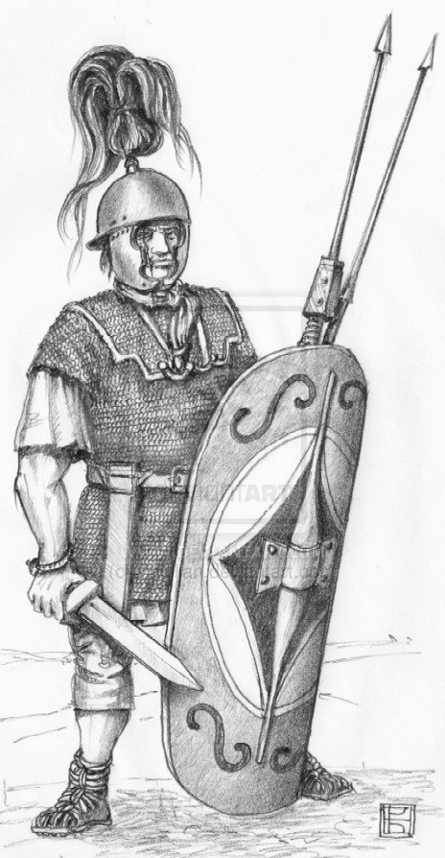
True or False
Legionaries could march 25 miles a day.
Legionaries would build a camp of earth walls on every day of the march.
Legionaries were very lazy.
Legionaries fought as a single man on his own.
Legionaries fought as big units of men.
The Romans invaded Britain because they wanted more land.
The Roman army came to Britain for a holiday.
The Army lived on meat, beans and grains.
The Army lived on pizza and burgers.
There were 80 men in a century.
Some British tribes were friendly to Rome.

