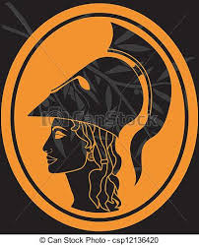Remember…

**Alphabet**

**α** alpha

**β** beta

**γ** gamma **Diphthongs**

**δ** delta

**ε** epsilon **αι** – as in “aisle”

**ζ** zeta **αυ** – as in “cow”

**η** eta **ει** – as in “eight”

**θ** theta **ευ** – as in “feud”

**ι** iota **οι** – as in “foil”

**κ** kappa **ου** – as in “food”

**λ** lambda **υι** – as in “queen”

**μ** mu

**ν** nu

**ξ** xi (ks) **Breathings**

**ο** omicron

Smooth breathing: **᾿**

**ἀ**τ = ‘at’

Rough breathing: **῾**

**ἁ**τ = ‘hat’

**π** pi

**ρ** rho

**σ/ς** sigma

**τ** tau

**υ** upsilon

**φ** phi (f)

**χ** chi (ck/ch)

**ψ** psi

**ω** omega

C:\Users\710382\AppData\Local\Microsoft\Windows\Temporary Internet Files\Content.IE5\8X44FL6F\MC900435137[1].wmf

|  |  |  |
| --- | --- | --- |
|  | **Subject** | **Object** |
| **Masculine** | -ος | -ον |
| **Feminine** | -η | -ην |