Can you colour this Christmas scene in the correct colours?
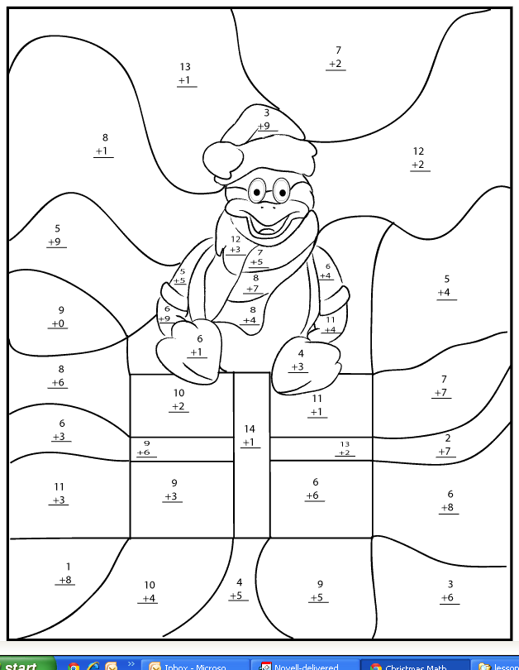
Sex + sex =
Novem + tres =
Sex + tres =
Octo + sex =
Unus + octo =
Decem + quattuor =
Novem + quinque =
Tres + sex =
Sex + octo =
Septem + septem =
Decem + duo =
Octo + sex =
Septem + duo =
Quinque + quattuor =
Octo + sex =
Novem + quinque =
Septem + duo =
Septem + septem =
Octo + unus =

15 = green (viridis) 10 = black (ater)
14 = dark blue (caeruleus) 9 = light blue (azureus)
12 = red (rubeus) 7 = orange (luteus)

