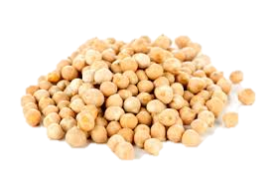
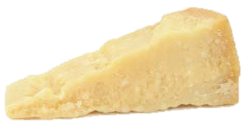
‘Erebinthoi syn Xeroi Tyroi’
Chickpeas and Cheese

Ingredients:

50g Chickpeas
25g Grated Parmesan Cheese
Olive Oil
Salt
Black Pepper

Method:
1. Soak the chickpeas in water for about 3 hours. Then drain and place in salted water.
2. Bring the water to a boil and cook for 40 minutes or until tender. Drain the water and allow to cool slightly.
3. Meanwhile grate the cheese and add some black pepper.
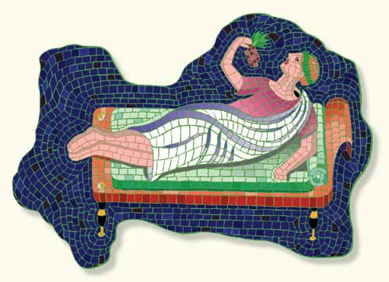
4. Add the cheese to the chickpeas and mash with a fork. Add a little olive oil, mix this in and serve whilst still warm.

