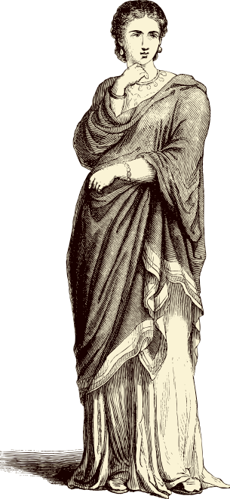
The Thieves of Ostia
Flavia Gemina solved her first mystery on the Ides of June in the tenth year of the Emperor Vespasian.
She had always had a knack for finding things her father lost: his best toga, his quill pen, and once even his favourite dagger. But this time there had been a real crime, with a real culprit.
It was a hot, still afternoon, for the sea-breeze had not yet risen. Flavia had just settled herself in the garden by the fountain, with a cup of peach juice and her favourite scroll.
'Flavia? Flavia!' Her father's voice came from the study.
Flavia took a sip of juice and quickly scanned the scroll to find her place. She would just read one or two lines. After all, the study was so close, just the other side of the fig tree. Her house - like many others in the Roman port of Ostia - had a secret garden at its centre, invisible to anyone on the street. From that inner garden it was only a few steps to the dining room, the kitchen, the store-room, a small latrine, and the study.
'Flavia!'
She knew that tone of voice.
'Coming, pater!' she called. Hastily, she set down her cup on the marble bench and placed a pebble on the open scroll to mark her place.
In the study, her father was desperately searching through various scrolls and sheets of paper on the table. Although Marcus Flavius Geminus was much more organised on his own ship, on land he was very forgetful.
'Oh pater!' Flavia tried to keep the impatience out of her voice. 'What have you lost now?'
'It isn't lost! It's been stolen!'
'What? What's been stolen?'
'My seal! My amethyst signet-ring! The one your mother gave me!'
Can you answer these questions?
- Where does Flavia live?
______________________________________________________________________________
- What word does Flavia use to mean father?

______________________________________________________________________________
- What has been stolen?
______________________________________________________________________________
- What items had been lost by her father before this one? Can you list them?
______________________________________________________________________________
- How was that afternoon described?
______________________________________________________________________________
- What was Flavia’s father do for a living?

______________________________________________________________________________
- What did many roman houses in Ostia have in their centre?

______________________________________________________________________________

The Story of the Cyclops’ Cave
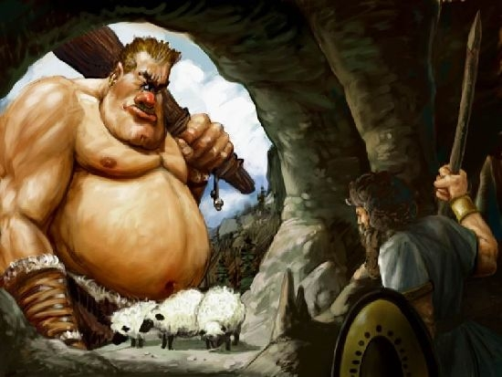
The first thing he did was drag a huge boulder into the mouth of the cave. Twenty horses could not have moved it. Then he milked his cows, so that he would have something to drink with his dinner. It was when he sat by his fire for the meal that he saw my men and I.
'Who are you?' asked a voice like thunder.
'We are Greeks, blown off course on our way home from Troy,’ I told him. ‘Will you be kind enough to let us stay in your cave?’.
The Cyclops did not like this at all and he snatched up two of my men and ate them whole.
They cried aloud to Zeus, for all the good it did our friend. The Cyclops washed them down with a drink of milk, licked his lips happily and went to sleep.
That night the rest of the men were scared they would also be eaten and were glad when morning arrived. They then watched the Cyclops make breakfast of two more of our friends. When he went out to look after his sheep, he closed the boulder behind him.
It was up to me to make a plan. I found a tree trunk that the Cyclops intended for a walking stick. Odysseus sharpened it so that it had a sharp point and then hid it in the back of the cave.
That night we gave so much wine to the Cyclops so that he fell asleep and did not notice Odysseus and his men moving around him.
This is when they got their sharpened stick and stabbed the Cyclops in the eye with it blinding him.
Can you answer these questions?
- Who is the story about?
______________________________________________________________________________
- What animals does the Cyclops look after? There are two different kinds!

______________________________________________________________________________
- What did the Cyclops do before seeing Odysseus and his men?
______________________________________________________________________________
- What covered the door to the cave keeping the Greeks from escaping?
______________________________________________________________________________
- Which god did they cry out for when the first two men were eaten?
______________________________________________________________________________
- How did they beat the Cyclops?
______________________________________________________________________________

