The Thieves of Ostia
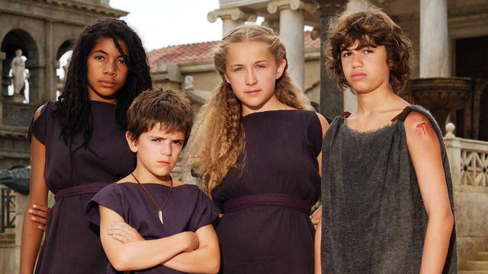
Flavia Gemina solved her first mystery on the Ides of June in the tenth year of the Emperor Vespasian.
She had always had a knack for finding things her father lost: his best toga, his quill pen, and once even his favourite dagger. But this time there had been a real crime, with a real culprit.
It was a hot, still afternoon, for the sea-breeze had not yet risen. Flavia had just settled herself in the garden by the fountain, with a cup of peach juice and her favourite scroll.
'Flavia? Flavia!' Her father's voice came from the study.
Flavia took a sip of juice and quickly scanned the scroll to find her place. She would just read one or two lines. After all, the study was so close, just the other side of the fig tree. Her house - like many others in the Roman port of Ostia - had a secret garden at its centre, invisible to anyone on the street. From that inner garden it was only a few steps to the dining room, the kitchen, the store-room, a small latrine, and the study.
Questions
1. List 3 things Flavia once found that her father lost.
I. II.
II.
2. How was that afternoon described?

3. Put ticks to show which statements are true and which are false. | True | False
Flavia solved her first mystery in the fifth year of Emperor Vespasian.
Flavia was sat by the fountain when her father called her name.

Flavia was drinking a cup of apple juice.

Ostia is a Roman port.

'Flavia!'
She knew that tone of voice.
'Coming, pater!' she called. Hastily, she set down her cup on the marble bench and placed a pebble on the open scroll to mark her place.
In the study, her father was desperately searching through various scrolls and sheets of paper on the table. Although Marcus Flavius Geminus was very organised on his own ship, on land he was very forgetful.
'Oh pater!' Flavia tried to keep the impatience out of her voice. 'What have you lost now?'
'It isn't lost! It's been stolen!'
'What? What's been stolen?'
'My seal! My amethyst signet-ring! The one your mother gave me!'
Questions
4. Read the above section again and underline the phrase that tells you that Flavia’s father is a sea captain.
5. What word does Flavia use to mean father?

6. What did Flavia’s mother once give her father and what has happened to it?

