**Exercise Two**

More vocab:

1. εἰμι – I am
2. εὑρισκω – I find
3. λαμβανω – I take
4. λειπω – I leave
5. λυω – I release
6. μανθανω – I learn
7. μενω – I stay, I remain
8. τασσω – I draw up, I arrange
9. ϕευγω – I run away
10. κελευω – I order

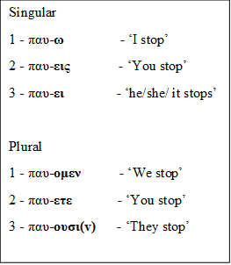



Exercise   
Pay attention to the person endings. With second persons, indicate e.g. ‘you (sg)’ or ‘you (pl)’

1. μανθανεις…………………………………………..
2. τρεχ-ομεν ……………………………………….....
3. μενουσιν…………………………………………….
4. κελευετε……………………………………………..
5. εἰμι ……………………………………………………
6. λαμβανομεν ……………………………………….
7. βαιν-ουσιν …………………………………………
8. διδασ-ει ……………………………………………..
9. λειπετε ……………………………………………….
10. ϕευγομεν …………………………………………..