The “Moves” for Cotton Eyed Joe
Singular
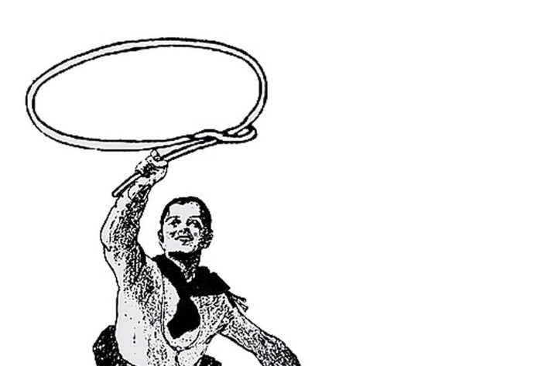
1). Whip up that lasso

2). Throw that lasso
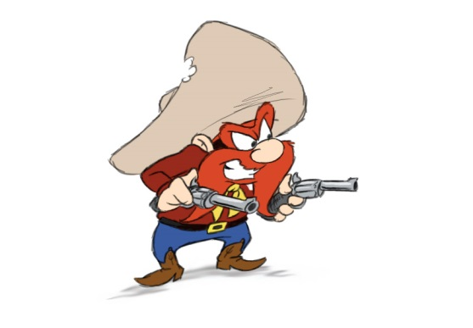
3). Get those guns out, and fire away three times in each direction to the rhythm of he/she/it
Plural
- Grab your partner and Dosey Doe Cotton Eyed Joe style

2). Line up on your Cowboy or Indian side, and ride that horse!

3). All together make your loudest Indian noise!
