Daphne and Apollo
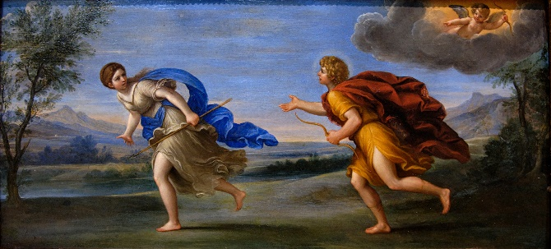
Cupido, iratissimus, ex pharetra duas sagittas carpit.
__________________________________________________________________________________________Aurea sagittal amoren facit, plumbea sagittal amorem delet.__________________________________________________________________________________________________________________________________ Cupido plumbeam sagittam in nympha figit, et auream sagittam in Apollone figit. ___________________________________________________________________________________________________________________________________ __ Statim Apollo nympham amat, sed mypha currit.
__________________________________________________________________________________________Deus clamat “Nympha, mane! ____________________________________________Non ego sum agricola, non greges observe.
__________________________________________________________________________________________Iuppiter est meus pater!”
_____________________________________________

