Design your own festival!
You have been given 2000 sesterce by the Emperor and it is your job to design a festival to any of the Roman gods.
Remember, you’ll need to entertain people as well as the gods so spend your money wisely!

First, pick a god to dedicate your festival to!
-Jupiter -Neptune -Pluto -Hera
-Apollo -Diana -Bacchus -Mars
-Minerva -Venus -Mercury

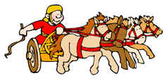
How will you entertain your god?
-Gladiators; 700 sesterce
-Poetry; 400 sesterce
-Theatre; 800 sesterce
-Chariot Races; 600 sesterce
-Wrestling and sports; 500 sesterce
-Dancing; 300 sesterce
Will you offer your god presents?
-Animals; 500 sesterce
-Clothes; 300 sesterce
-Wine and food; 400 sesterce
-Weapons and armour; 600 sesterce

The Emperor has also told you to draw a picture so everybody can remember your festival forever!

