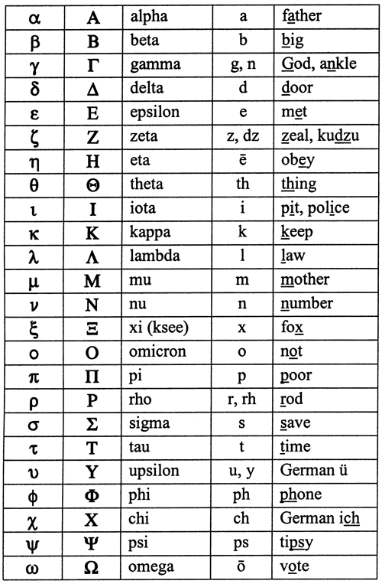
The Greek Alphabet:

Try and write your name in Ancient Greek:
..........................................................................................................................................................................................................................................................................................................................................................................................................................................................................................................................................................................................................................................................................................................................................................................................................................................................................................................................................................................................................................................................................................

