Echo and Narcissus
Echo was a beautiful nymph who was fond of talking and in every conversation liked to have the last word. One day, Juno was angry and looking for Jupiter, when Echo tried to distract her by talking. This made Juno angrier, and she punished Echo by removing her power to speak first, only to reply so she would always have the last word.
Echo saw a young man named Narcissus and fell in love with him. She long to speak to him, so she followed him and waited patiently for him to notice her and speak to her first so that she could reply. One day he noticed her and asked her to come to him, only to reject her and say “Hands off! I would rather die than love you!”
After Narcissus left her, Echo ran away crying, and because she was so upset she lived only among caves and mountain cliffs where she would be alone. She felt such grief that her body faded away and her bones changed into rocks, so nothing was left of her but her voice. She waited in caves and near cliffs to reply to anyone who might call her, and always has the last word.
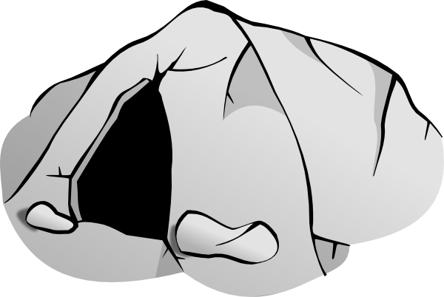
1. Describe Echo in your own words

2. What is the story explaining the meaning of, and how is this made obvious?

3. Why does the story say that Echo lived in places like caves and mountain cliffs?
Narcissus continued upsetting all of the other nymphs when he met them. One day, one of them was so upset by this that she said a prayer hoping that one day he would know the pain of loving and not being loved in return.
Very soon, Narcissus was hunting and went to a clear fountain to fetch a drink. When he knelt down to reach the water, he saw his own reflection, but thought it was a spirit living in the water. He thought this spirit was so beautiful that he fell in love with himself.
He tried to kiss and to embrace what he thought was the creature, but whenever he touched the water it disappeared. After a moment it would return, and he could not bring himself to leave the fountain. Eventually he became tired and hungry, and asked the spirit why it did not love him. He cried, which disturbed the reflection in the water. He remained upset, and lost his health and his beauty. He wasted away and died, and the nymphs all cried as they mourned his death.

4. True or false?
Narcissus saw a spirit in the fountain
The nymphs cried over Narcissus because he was their friend
Narcissus died because he could not leave the fountain

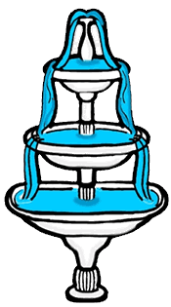
5. Describe Narcissus in your own words

