amo aviam.
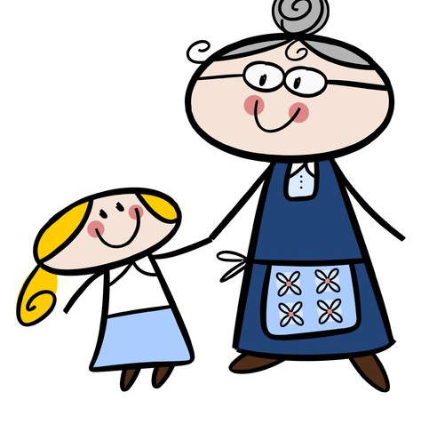
I love my grandmother.
frater amat ludum.

My brother loves school.
beatus est.


He is happy.
pater amat cenam.

My father loves dinner.
sum miser.

I am sad.
sum filius.

I am the son.
sum fessa.


I am tired.
docta est.

She is clever.
coquus est bonus.

The cook is good.
pater est fortis.

My father is brave.
mater est pulchra.

My mother is beautiful.
servus est doctus.

The slave is clever.
filia est lavisciva.

The daughter is playful.
avus est antiquus. 
My grandfather is old.
frater non est bonus. 
My brother is not kind.

