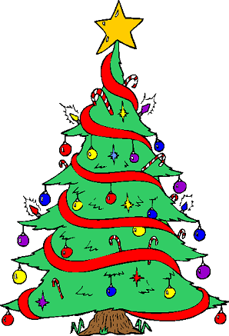
FIND THE LATIN MISTAKES!
Certain nouns and adjectives that we have already seen are highlighted. SOME of these are in the wrong case i.e. nominative or accusative. Using the help sheet and working out if the word is the SUBJECT or DIRECT OBJECT see if you can find and CORRECT any Latin mistakes!

‘T was the night before Christmas

Est Nox ante festum nativitatis Christi

And all through the house
Et in domo

Not an animal was awake, not even a small mouse

Nulla bestia evigilat, neque parvam mus

The sacks were hung by the chimney with care

Sacci suspenduntur prope caminum diligenter

With the hope that Santa soon would be there

spe: Santa mox est hic

The children were all asleep in their beds

Pueri dormiunt in lectulis

Visions of presents danced in their heads

Spectra donorum saltant in capitibus

The moon was bright on the new-fallen snow

Luna est luminosam super novam pruinam

It gave the light of mid-day to objects below

Dat lucem merīdiēī objectis inferis

And then, suddenly, I heard on the roof

Et subito, audio in tecto

The prance and sound of each little hoof

Saltum et sonitus parvae ungulae

When I was afraid, and turning around

Cum timeo et converto

Santa came down the chimney with a bound

Santa descendit de camino cum salto

He was dressed all in fur, from his head to his foot

Vestitus est in pelle, a capite ad pedem

And his clothes were all black with ashes and soot

vestes omnia nigria cineri et fuligini

His eyes - how colourful! His dimples how merry!

Oculi – quam luminosus! Facies quam hilaris!

His cheeks were like red roses, and he wasn’t very smelly!

Genae ut rubea rosae, et ille non odoratus!

He spoke not a word, but went straight to his work,

Dicit nullum verbum, sed it ad laborem,

And filled all the sacks, as much as he pleased

Et implet omnes saccos, quantum placet

He ate a lot of wine, nuts and cheese

Comsumit multum vinus, nuces et caseus

And giving a nod, up the chimney he rose

Et nutus, sursus caminum surgit

But I heard him exclaim, when he wasn’t in sight

Sed clamat, cum non adest

"Happy Christmas to all, and to all a good-night!"

“Felix festum nativitatis Christi omnibus, et omnibus felix nox!”
