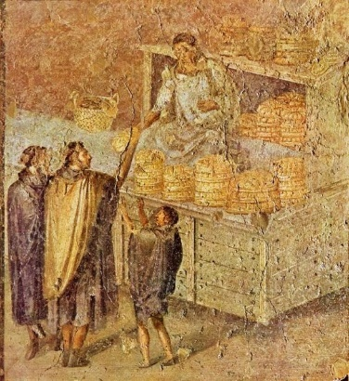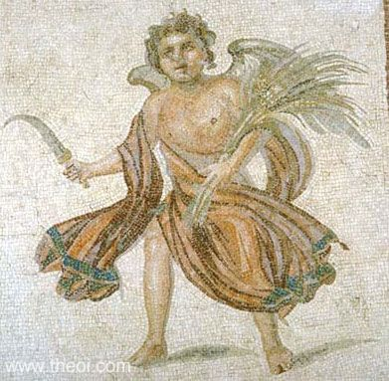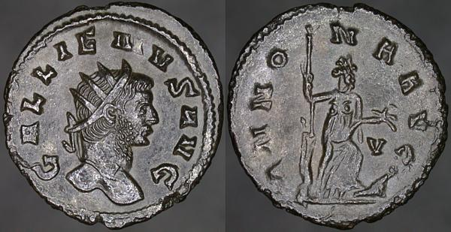

Who? – **Gallienus** (emperor with his father, Valerian, from 253-260 AD; emperor alone from 260-268 AD) and **Annona**, goddess of Roman grain trade

What? – Coin

Where? – **Rome**

When? – 3rd century AD (between 260-268 AD)

Who? – **Theos**, God of Summer

What? – Floor mosaic

Where? – The House of the Drinking Contest, **Antioch**

When? – 3rd century BC

Who? – **Baker and customers** in the bakery

What? – Wall painting

Where? – **Pompeii**

When? – 1st century AD (50-75 AD)

**“Pour 1/2 pound of clean wheat into a clean bowl, wash well, remove the husk thoroughly, and clean well. Pour into a pot with pure water and boil. When done, add milk slowly until it makes a thick cream.”**

Porridge recipe from ‘De Agri Cultura’ by Cato the Elder. Written around the year 160 BC.

Who? – **Slaves** carrying food for a banquet

What? – Mosaic

Where? – **Carthage**

When? – Late 2nd century AD

What? – **Pistrinum** (bakery) belonging to N. Popidius Priscus. 1 of 33 found in Pompeii.

Where? – **Pompeii**

When? – 1st century AD

What? – **Thermopolium** (hot food shop) of Asellina

Where? – **Pompeii**

When? – 1st century AD

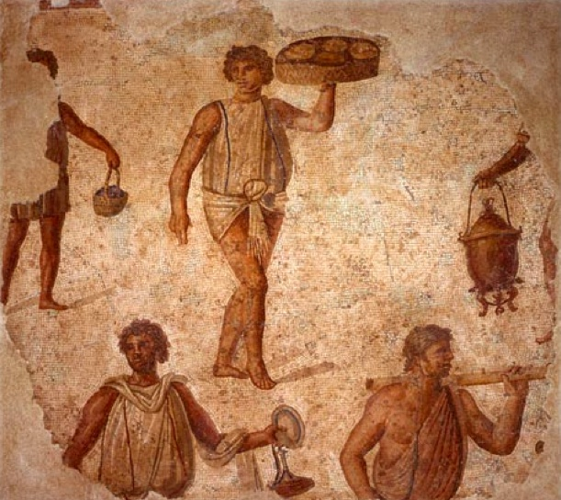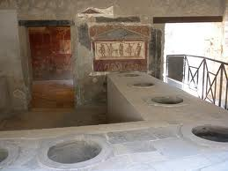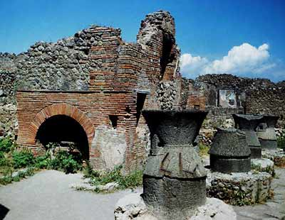

**"After a generous rubdown with oil, we put on dinner clothes. We were taken into the next room where we found three couches drawn up and a table, very luxuriously laid out, awaiting us.**

**We were invited to take our seats. Immediately, Egyptian slaves came in and poured ice water over our hands. The starters were served. On a large tray stood a donkey made of bronze. On its back were two baskets, one holding green olives, and the other black. On either side were dormice, dipped in honey and rolled in poppy seed. Nearby, on a silver grill, piping hot, lay small sausages. As for wine, we were fairly swimming in it."**

Dinner party description: adapted translation from ‘Satyricon’ by Petronius, written in the late 1st century AD.