Roman Meals for the Rich!

What would the rich Roman have for breakfast (jentaculum)? _________________________________________________________________________________________________________________________________________________________________________________________________________________________________
What would they have as an early lunch at 11:00am (prandium)? _________________________________________________________________________________________________________________________________________________________________________________________________________________________________
What was served for a Roman dinner (Cena) and how long might it last? ____________________________________________________________________________________________________________________________________________________________________________________________________________________________________________________________________________________________________________
The writer Petronius wrote about his eating experiences in around AD 60:
"After a generous rubdown with oil, we put on dinner clothes. We were taken into the next room where we found three couches drawn up and a table, very luxuriously laid out, awaiting us.
We were invited to take our seats. Immediately, Egyptian slaves came in and poured ice water over our hands. The starters were served. On a large tray stood a donkey made of bronze. On its back were two baskets, one holding green olives, and the other black. On either side were dormice, dipped in honey and rolled in poppy seed. nearby, on a silver grill, piping hot, lay small sausages. As for wine, we were fairly swimming in it."
Which foods would you like to eat at a Roman Cena? ________________________________________________________________________________________________________________________________________
Which foods wouldn’t you like to eat?
________________________________________________________________________________________________________________________________________

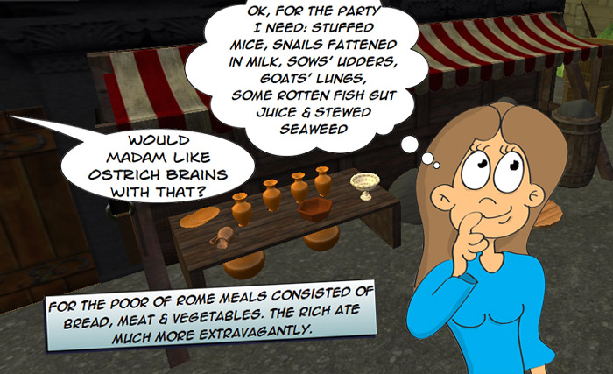

What was eaten by poor people in ancient rome?
So, what did those poor Romans eat? ………………………………………………………………………………………………………………………….
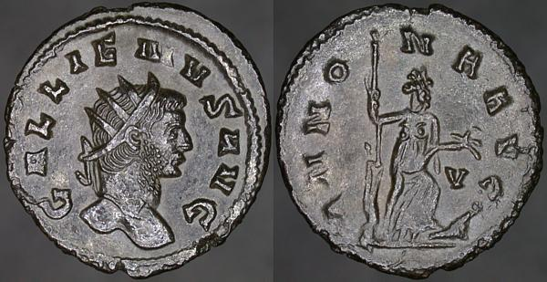
Who was Annona?………………………………………………
……………………………………………………........................
How did annona coins help poor Romans? ……………………………………………………………….........
…………………………………………………………………….
…………………………………………………………………….
…………………………………………………..………………………………………………………………………………………………………………………………………………………………………………………………………..

Name 2 reasons why we know what the Romans ate. 1)………………………………………………………………………………………………………………………..………………………………………………………………………………………………………………………………..
2)…………………………………………………………………………………………………………………………..……………………………………………………………………………………………………………………………..
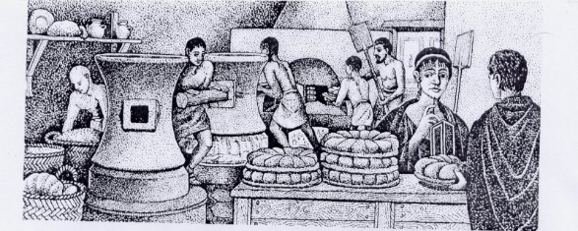

Roman recipes from ‘de agricultura’ by Cato the elder
Would you like to eat like a poor Roman? Give 2 reasons why (or why not!).
“Rations for farm-workers: four modii of wheat in winter, with which to make the nodi ollae. The overseer, housekeeper, foreman and shepherd should receive three.”
“Pour 1/2 pound of clean wheat into a clean bowl, wash well, remove the husk thoroughly, and clean well. Pour into a pot with pure water and boil. When done, add milk slowly until it makes a thick cream.”
________________________________________________________________________________________________________________________________________________________________________________________________________________________________________________________________________________________________________
Roman Eating Habits
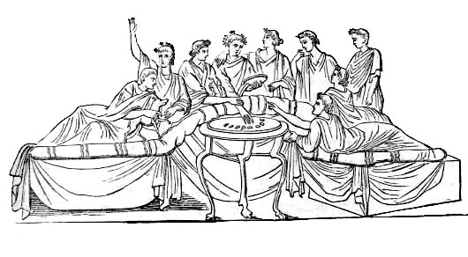
Q.1. Who prepared the meals in a…. rich household?__________________________________________________
… very poor household?_____________________________________________
Q.2. Where would the Romans buy their food? ______________________________________________________
Q.3. What types of food could be bought there? _____________________________________________________
_____________________________________________________________________________________________
Q.4. In the early Roman Empire people sat on stools to eat their food. What did this change to?_______________
Eating Out
It was only the wealthy Romans that dined at banquets. The poorer Romans enjoyed eating out at fast-food places just like we do today.
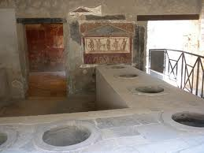
To the left is a Roman fast-food joint in Pompeii. You can see a colourful picture in red and yellow (just like McDonalds). The circular holes would have contained various foods.
What signs were found above fast food restaurants in Pompeii? __________________________________________________________________________________________________________________________________________
What did the Romans Use for sauce? ______________________________________________
What dishes would be served in these fast food places?
____________________________________________________________________________________________________________________________________________________________________________________________________________________________________________________________________________________________________________
How healthy was the roman diet?
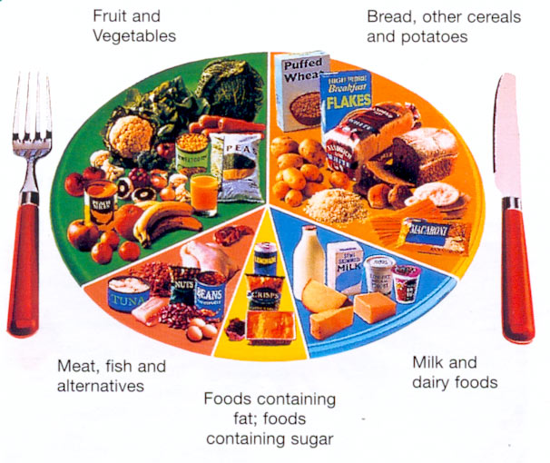
Eating healthily is a big part of living a healthy lifestyle. You might have seen something like this picture before. It shows how much of different food types we should eat to stay healthy: lots of fruits and vegetables, as well as bread, cereals and potatoes, some dairy foods (like milk and cheese) and fish and meat (or alternatives, if you’re vegetarian/vegan), and not a lot of fatty or sugary foods at all!
If we keep this plate in mind, we know how healthy the food that we eat is, but what about the Romans? Did they eat healthily or not? Let’s find out!

What foods do you also eat that the rich Romans ate? _____________________________________________________________________________________________________________________________________________________________________________
What foods did poor Romans eat most often? _____________________________________________________________________________________________________________________________________________________________________________
Give 2 reasons why there was such a big difference in the types of foods eaten by the Romans.
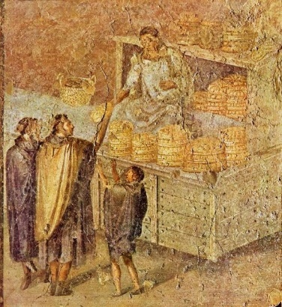
1)…...…………………………………………………………………………………………………………………….………………………………………………………………………………………………………….2)..…….…………………………………………………………………………………………………………………………………………………………………………………………………………………………......
What is this a painting of? ____________________________________________________
Was this an important place for rich, poor, or all Roman people? Why? ..............................................................................................
…………………………………………………………………….
…………………………………………………………………….
…………………………………………………………………….
…………………………………………………………………….
…………………………………………………………………….
…………………………………………………………………….
What do you think?
Did poor Romans eat healthily? Why? ____________________________________________________
____________________________________________________________________________________
Were richer Romans more or less healthy eaters than poor Romans? Why? ________________________
______________________________________________________________________________________________________________________________________________________________________________

