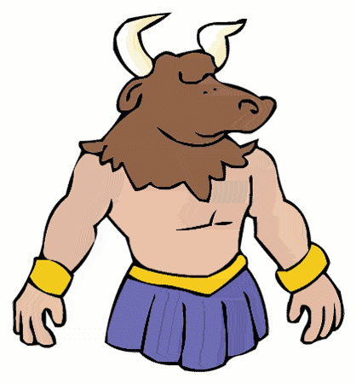
Theseus and the Minotaur

This is the μυθος of an evil king called Μινως, and the people had φοβοv of him. He had a Μινωταυροv that lived in his λαβυρινθος. He needed a κουρον and κορην, seven of each, from Ἀθηνη. He wrote to the army about taking the children. The ἐπιστολη was sent by a man on a ἱππος. Θησευς stepped forward and said he would take the place of a κουρον being taken. The θανατος of the monster was not easy. Θησευς
had help from Ἀριαδνη so he would not get lost in the λαβυρινθος. The φωνη was that of happiness when the people heard that the Μινωταυρος had died. The villagers got home safely to their families. The End.

Write your own story about the Minotaur below using the vocabulary above.
Write two sentences using one subject and object in each.

