Hannibal enters Italy
Hannibal was a general from Carthage in the Second Punic Wars. He became famous for surprising the Roman troops after crossing the Alps into Italy.
Hannibal reached the hills without any opposition from local tribes. As his army moved forward, the local tribesmen appeared. Hannibal ordered them to halt and sent his guides to talk to the tribesmen. They told him he would not be able to cross the Alps here, but his guides listened in to the conversations of the tribesmen and discovered that the pass was only protected by day. So Hannibal made a camp at the base of the hills. Once he was sure the tribesmen had left the heights, he took the hills that the tribesmen had been defending.
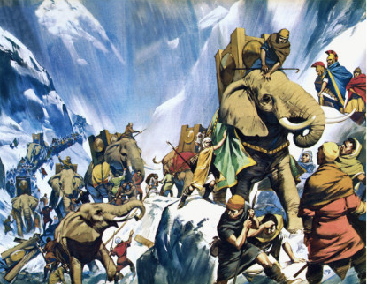
The next morning, the tribesmen were surprised to find the troops from Carthage had passed them but they also noticed that there was a lot of confusion among the men, so the tribesmen decided to attack them. Hannibal and his army scattered the tribesmen, restored order and Hannibal brought his whole army through the pass.
Hannibal and his troops only faced small raids after this until they reached the top of the mountain. Once there their difficulties did not get better, as it had begun to snow. Hannibal gave his troops an encouraging speech and they began the journey into Italy. The track on this side of the mountain was much steeper and the troops struggled to get down without falling down the mountain. Eventually Hannibal and his troops made it down the mountain and camped on the plains at the bottom.
Hannibal had crossed the Alps with most of his troops and was now in Italy.
Questions
How did Hannibal get past the tribesmen’s outpost?

How long was Hannibal cut off from his baggage train?

What troubles did Hannibal and his troops face once they were over the top of the mountain?

