Birth of the gods
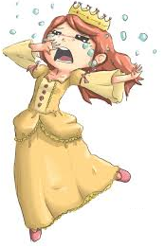
Before the gods ruled the world there were a race of beings called the Titans who were big and strong. The king was a cruel titan named Saturn who was married to a titan named Opis who was loving and caring.
Saturn was told that one day one of his children will stop his cruel reign which scared him. To make sure he was always king he ate all his children as they were born which included Juno, Neptune and Pluto. This made Opis very sad as she had no children to love!
She asked her parents to help her out and they came up with a plan to trick Saturn and defeat the evil king for good. They decided to hide the next child from Saturn so that he would not be able to eat him. When Opis was about to give birth, her parents hid her on an island called Crete where Jupiter was born in secret.
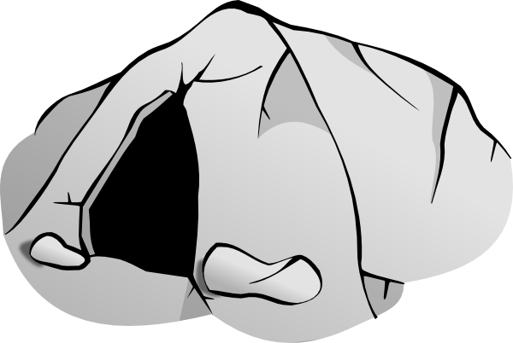
Opis decided to give Saturn a stone wrapped in baby clothes to eat to trick him. Saturn being greedy gobbled up the stone without looking and he forgot all about his wife being pregnant with baby Jupiter.
Jupiter grew up on the island of Crete hiding in woods and in caves until he became big and strong enough to defeat his evil father Saturn.

When Jupiter was strong enough, he challenged his evil father to a fight and defeated him. After he defeated Saturn, Jupiter cut open his stomach to free his brothers and sisters. After the battle, Jupiter was made king of the Earth and went to live on Mount Olympus where he watched over the Romans.

Questions!
- Who was Saturn?

__________________________________________________________________
- Why was Opis sad?

__________________________________________________________________
- What plan did Opis come up with to save Jupiter?
__________________________________________________________________
- Do you think Jupiter should of beaten his father? If so, why?

__________________________________________________________________
- Do you think Jupiter will make a good King of the Earth? If so, why?

__________________________________________________________________
- Do you like the story? Yes or No?
__________________________________________________________________
Draw your favourite scene!

Highlight any words that you find difficult and write them below. Write what they mean:
Reign _______________________________________________________________
Devised _____________________________________________________________
_________________________________________________________

