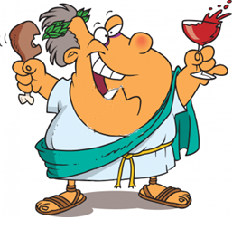
Homework
The Roman writer Patronius went to a banquet with his friends. After being rubbed with oil and given dinner clothes, he was taken into a room with many seats and a table awaiting them.
"The starters were served. On a large tray stood a donkey made of bronze. On its back were two baskets, one holding green olives, and the other black. On either side were dormice, dipped in honey and rolled in poppy seed. Nearby, on a silver grill, piping hot, lay small sausages. As for wine, we were fairly swimming in it."

I) What were the dormice dipped in?

II) What were the two types of olives that were served?

A. B.

III) What metal was the donkey made of?

IV) Do you think the dormice were cooked in a pan or an oven?

v) Does this sound like a nice dinner? Why (not)?
___________________________________________________________

