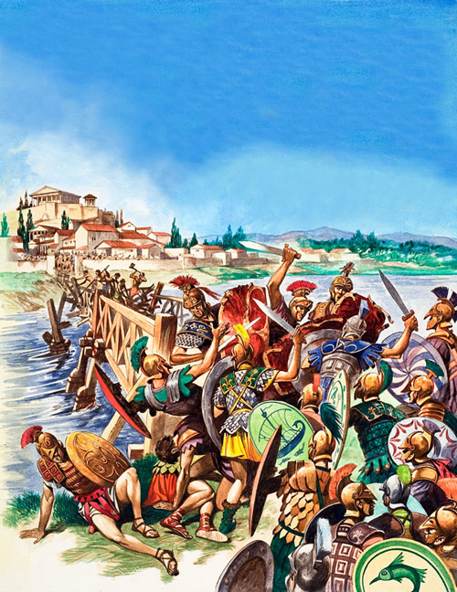
Horatius and the Bridge.
Tarquin the Proud was the last king of Rome.
He was mean to his people so they threw him out of Rome.
Tarquin got help from a near-by tribe called the Etruscans, who lent him an army.
Tarquin and his new army surprised the people of Rome with an attack.
The farmers fled their fields into the city of Rome across the wooden bridge above the river Tiber.
Once inside the city everyone was panicking and they forgot to burn the bridge.
Tarquin and his Etruscan army would be able to get into Rome easily.
A brave young soldier named Horatius told his friends to chop down the bridge while he faced the Etruscan army on his own.
The bridge was so narrow that he was able to defend it with the support of only two friends.
Once the bridge began to give way his friends ran back and Horatius dove into the Tiber.
The Etruscans saw this as a sign from the gods that Rome was a divine city not to be attacked.
They ignored Tarquin’s complaints and went home.
The Roman people vowed never to be ruled by a king again.

Questions
Who was Tarquin the Proud?
________________________________________________________________
Can you connect the names on the left to the correct event on the right?
Tiber | The neighbouring tribe that lent Tarquin troops
Etruscans | The brave solider who defended the bridge into Rome
Horatius | The river that runs through Rome

What did the people of Rome vow after Horatius had defended the bridge?
________________________________________________________________

