Horrible Histories: Come Dine With Me Questions

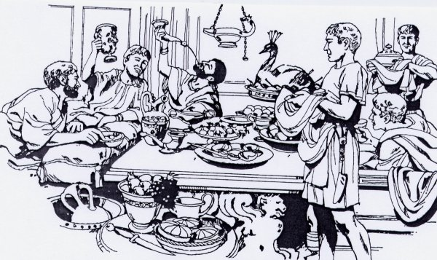
What food can you see in the video?

Who cooks the food? Where?

What are some of the strange foods mentioned in the video?

Which food mentioned would you most want to try at a Roman dinner party?

