“I Am Spartacus”
Please read the boxed text and answer the questions which follow.
Spartacus was once a soldier in the Roman army in a land called Thrace, but he didn’t enjoy life in the legion and so he tried to escape. The punishment for this was to be sold into slavery. He was sold as a slave to a gladiator school. However, Spartacus also didn’t want to be a gladiator and so he and his fellow gladiators escaped. They took weapons from the school and set up camp at a volcano named Vesuvius. Here they gathered up other escaped slaves from the area.

- Why was Spartacus sold into Slavery? (Circle the Right Answer)

Stealing Weapons Trying to Escape Not Enjoying Life

The local Romans were really scared because at the time there were more slaves than freed men living in and around Rome. They were afraid that Spartacus would free all the slaves and kill the Romans so they sent an army to fight him. Spartacus and the other gladiators defeated the first Roman army. So the Romans sent a second army. Spartacus beat this one as well.

- What was so scary about Spartacus and the other Gladiators?

___________________________________________________________
___________________________________________________________

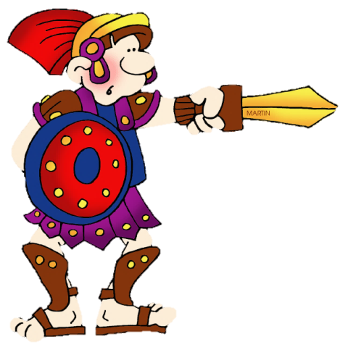
- Do you think Spartacus is a Hero or a Villain?

______________________________________________

- Put these events in the order that they happened in the story.
Over 4 years more than 100,000 slaves joined Spartacus and his gladiators. The Romans knew that they had to defeat Spartacus or they were doomed so they sent 3 armies to beat him. Spartacus was finally cornered and defeated by the Roman legions. The Romans sent a message to every slave in the empire by killing every slave that had joined Spartacus.

(Number 1-5)

Slaves joined Spartacus and his Gladiators.

The Local Romans were scared.

Spartacus was sold into Slavery.

The Romans sent a second army.

Spartacus escapes.

- Highlight the words you found difficult to read and write them below:

______________________________________________________________________________________________________________________

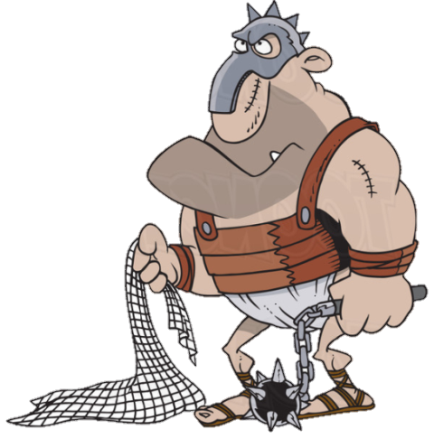
- Now create a new sentence using one of these words.

