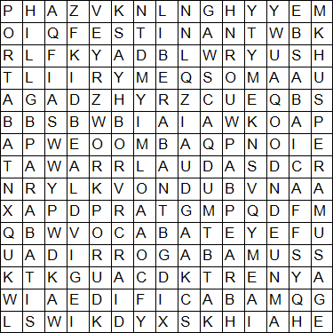
Imperfect Tense

AEDIFICAB____ – I built FACIA____– you (sing) make
FESTINA______ – I hurry LABOR_______ – I work
LAUD____ – You (sing) praise LIBERAB_______ – They freed
PARAB______– You (pl) prepared PORTAB______ – He carried
ROGAB________– We asked SERVAB______ – He served
SPERA________ – We hope VOCAB_______ – She called

