Homework - Create Your Own Sentences

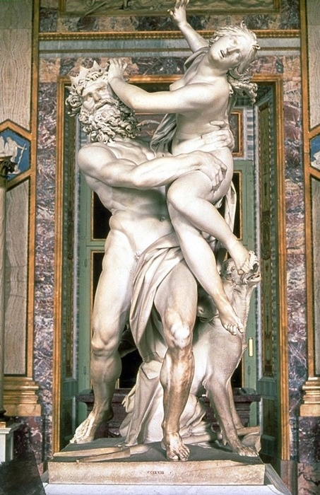
Using the four following verbs:

διωκ-ω | I chase
λαμβαν-ει | He/she/it takes
ἐχ-εις | You have
φερ-ομεν | We carry/bring

And the four following nouns:

ἐπιστολ-η | a letter
ἀγγελ-ος | a messenger
κωμ-η | a village
ἱππ-ος | a horse

Create your own Greek sentences. Remember, the subject must always be in the nominative, and the object in the accusative. See if you can turn it into a short story.

Example 1: διωκω (Ι chase) ἱππον (a horse)
Example 2: ἱππος (a horse) φερει (he brings) ἐπιστολην (a letter)

- ____________________________________________________________
- ____________________________________________________________
- ____________________________________________________________

