Be a language detective: can you answer these questions?
- What do these Greek words mean? Circle the answer you think is right.

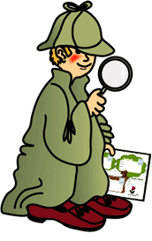  - παυω | - I start  - I stop  - I continue
- φωνη | - Phone  - Ear  - Voice
- νικη | - Victory  - Night  - Trainers
- φιλω | - I hate  - I love  - I feel

- Which English word do you think might come from the Greek word on the left?

- κρυπτω | - Cry  - Crew  - Cryptic
- ὑπνος | - Up  - Hypnosis  - Hyper
- ναυτης | - Nautical  - Nought  - Name
- φαρμακος | - Famous  - Farm  - Pharmacy

- Read through this text and see if you can answer the questions.
Ὁδυσσευς is in a cave when ἀκουει φωνην and ἐχει φοβον. It is the Κυκλωψ! ὁ Κυκλωψ eats κουρον and λεγει: “bring me δωρον!”. Ὀδυσσευς λεγει: “οἰνον φιλεις”. οἰνον πινει and falls into ὑπνον. They stab his ὀφθαλμον so he cannot find them. Ὀδυσσευς κρυπτει under a sheep and φυγει when the Cyclops leads them to the ἀγρον to graze. καλει: “νικην εχω!”

- Can you think of an English word that could have come from the Greek word for fear?
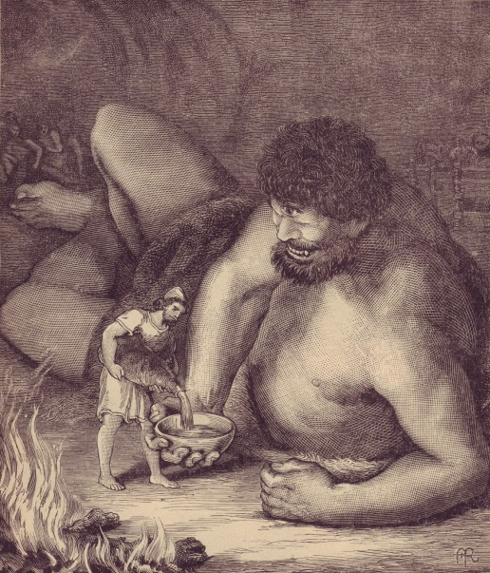
____________________________________

- Who loves wine?

____________________________________

- Which body part do you think the Cyclops is stabbed in?

a) His eyes
b) His ear
c) His eye

- If a man who escapes from prison is called a fugitive, what do you think φυγει means?

______________________________________

- Using the words and endings you’ve seen so far, have a go at figuring out these sentences and writing some of your own!
- ἐπιστολην γραφω

_____________________________________________

- ἱππον εχεις

_____________________________________________

- ποταμον μισει

_____________________________________________

4)
_____________________________________________________________________

_____________________________________________________________________

_____________________________________________________________________

Seen so far...
alphabet
diphthongs
breathings

Nouns: masc/fem/neut subj/obj singular
god/goddess
messenger
wine
word
story
horse
river
army
voice
music
victory
girl/boy
letter
gift
tree

Verbs: 1st, 2nd, 3rd sing
say
write
hear
have
hate
love
call
stop
hide
drink
eat

