If you want to be very Roman…

Io, Saturnalia! = Hurray, Saturnalia!
Laeta Saturnalia! = Merry Saturnalia!

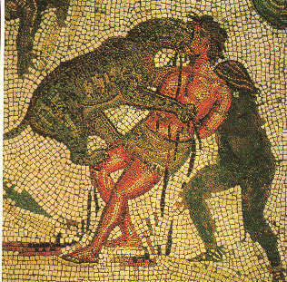
If you want to risk being thrown to the lions…

Hilare festum nativitatis Christi et felicem annum novum!
= Merry Christmas and a Happy New Year!
Omnia optima festo nativitatis Christi et felici anno novo!
= All the best for Christmas and for a Happy New Year!

If you want to focus on New Year…

Salutes temporis anni! = Greetings of the time of the year!
Beatum annum novum! = Happy New Year!
Fortuna tecum sit per annum novum! = May fortune be with you through the New Year!

Just in case you were wondering, because the Romans had no word for Christmas – we’ve had to say “festival of the birth of Christ”!

