Homework Sheet

Greek Word Written in Meaning English Derivatives/
English Related Words
φωνή | Phone | Voice | phonetic, telephone, xylophone
χρόνος |  | Time
πατήρ |  | Father
μόνος |  | Alone
γένεσις |  | Birth
βιβλίον |  | Book
Use your Greek alphabet worksheet to write out the Greek words in English then using the English spelling and the meaning, think of all the related English words you know.
Create Your Own English Sentences
Use Greek Words From The Charts Below
Include one subject and one object in your first sentence.
In the second, try using a Greek verb with the correct ending to show who is doing the action.

MASCULINE SUBJECT OBJECT FEMININE SUBJECT OBJECT
WINE | oἰνος | 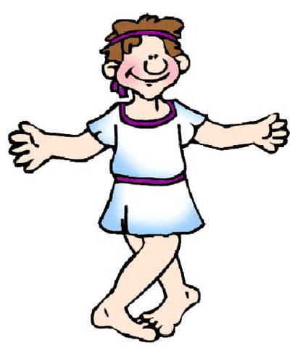  οἰνον
STORY | μυθος | μυθον
BOY | κόρος | κόρον
SLAVE | δουλος | δουλον
VOICE | φωνή | φωνήν
VILLAGE | κώμη | κώμην
GIRL | κόρη | κόρην

VERBS (1) I (2) YOU (3) HE/SHE/IT
HATE | μισω | μισεις | μισει
LOVE | φιλεω | φιλεις | φιλει
HAVE | ἐχω | ἐχεις | ἐχει

Sentence 1
________________________________________________________________________________________________________________________________________________________________________________________________________________________________________________________________________________________
Sentence 2
________________________________________________________________________________________________________________________________________________________________________________________________________________________________________________________________________________________

