Odysseus in the Underworld
Based on the Odyssey book 11

Ὀδυσσευς had been on the island of the beautiful witch Κιρκη for one year. Κιρκη λεγει: “In order for you to get home to Ithaca, you must πρωτον visit ῾Αιδης and seek the advice of the blind προφητης Tiresias.”
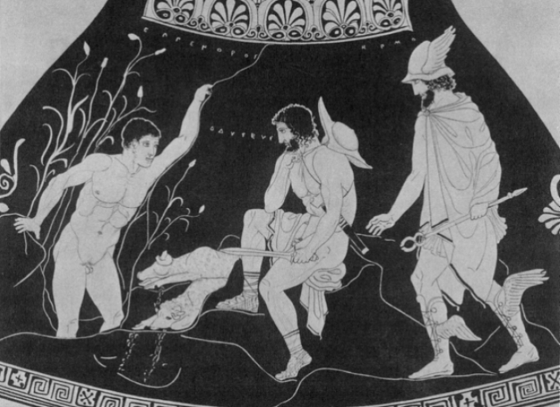
So Ὀδυσσευς sails in his ναυς to ῾Αιδης, and πρωτον he must perform a ritual. He digs a pit, and pours in milk, honey, οἰνος and water. He scatters some barley and vows to kill a βους in Ithaca upon his return. Then he λαμβανει a μεγας sheep and slits its throat: its blood drops into the pit on top of the offerings. A soul must drink the blood in the pit before he λεγει.

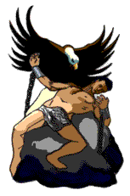
Lots of souls rush out and he sees a ναυτης that used to be on his ναυς. The ναυτης tells Ὀδυσσευς his μυθος. He drank too much οἰνος, fell off the roof of Κιρκη‘s οἰκος and broke his neck. When he ἀκουει the story, Ὀδυσσευς promises he will bury his νεκρος properly when he returns to Κιρκη’s island.

Then Tiresias drinks the blood and λεγει to Ὀδυσσευς about his future. Odysseus sees further into ῾Αιδης, and in Ταρταρος he sees souls being endlessly tortured. Tityos is tied to a λιθος and has his liver pecked out by vultures: it regrows every night and is pecked out again the next day. Tantalus stands by a lake and a δενδρον but cannot reach the fruit to eat or the water to drink so can never quench his thirst or hunger. Sisyphus is forced to roll a μεγας λιθος up a hill, only for it to fall down again. Ὀδυσσευς is overwhelmed by the souls and quickly returns from ῾Αιδης to the land of the living.

Exercise 1:
Link the Greek words with the English derivatives.
Can you then guess what the Greek words mean?

Greek English derivative meaning of the Greek word
πρωτον mythology great, big
λεγει lithography cow
προφητης megalithic stone
ναυς bovine first
οἰνος wine s/he takes
βους prototype s/he hears/listens to
μεγας acoustics s/he says/speaks
ναυτης lexicon tree
μυθος necromancer story
οἰκος prophetic ship
νεκρος dendrochronology prophet
λιθος nautical corpse
ἀκουει economy wine
δενδρον syllable house
λαμβανει sailor

Exercise 2:
Divide the words into the different categories of words.
Can you spot any similarities between them?
Look particularly at the endings of the words

Nouns | Verbs | Adjectives | Adverbs

Nouns: endings on _____________________________________

Verbs: ending on ______________________________________

