**Chapter 3: Subject and object**

**What can nouns do?**

**You all know that nouns are naming words…**

**but what do they DO in sentences?**

Nouns can play different parts in sentences.

In English, we have to look carefully at the whole sentence to see what part each word is playing,

but in Latin we only have to look at the end of words!

Nouns can be **SUBJECTS** and DIRECT OBJECTS.

The **SUBJECT** carries out the action of the *VERB*.

The DIRECT OBJECT undergoes the action of the *VERB*.



**The Romans** *spoke* Latin.

**The girl** *kissed* a frog.

**A kitten** *watched* television.

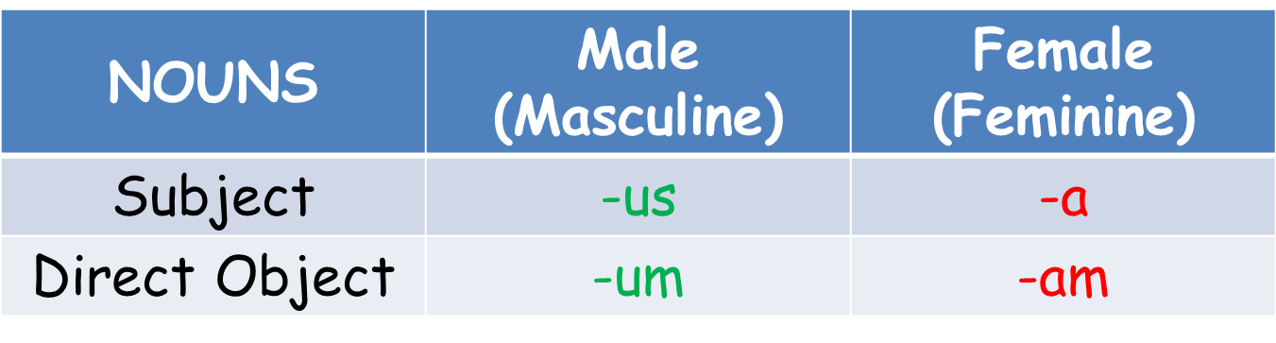

**Exercise 1: My name in Latin**

My name is… _____________________________

|  |  |
| --- | --- |
| My name is…  The name of the person to my left is… | |
| Subject |  |
| Direct Object |  |

1. Write a sentence using your name as the subject. Remember to add the correct ending to your name!
2. Write a sentence using your name as the direct object. Remember to add the correct ending to your name!

**Exercise 2: Invent your own noun!**

What noun have you chosen to reinvent? Try to think of a noun that wouldn’t have existed during the Roman Empire.

My noun is… _____________________________

|  |  |
| --- | --- |
| The declension of my noun is… | |
| Subject (called the nominative) |  |
| Direct Object (called the accusative) |  |

1. Write a sentence using your noun as the subject. Remember to add the correct ending to your noun!
2. Write a sentence using your noun as the direct object. Remember to add the correct ending to your noun!

**Exercise 3: fill in the ending and translate the sentences.**

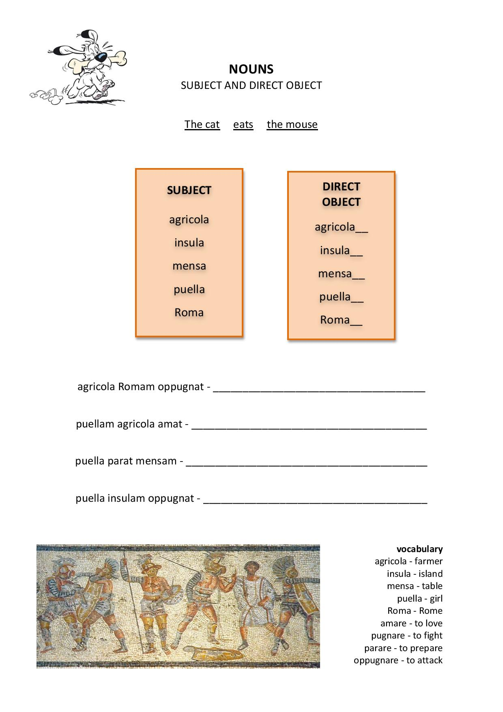

**Exercise 4: Matching cases**



Draw a line to match the correct endings:

**Mens-am Subject**

**Amic-us Subject**

**Naut-a Direct Object**

**Gladi-um Subject**

**Fili-am Direct Object**

**Puell-a Direct Object**

**Serv-us Indirect Object**

**Ann-um Subject**

Complete the sentence:

* Puell__________ cleared mens_______.
* Serv___________ stole gladi________.
* Naut_________ had no amic_______.

**Exercise 5: Challenge**

MC900084250[1]**Challenge 1**

Circle the **verbs** in these sentences.

1. The fox chased the chicken.
2. The girl drank the water and the boy ate the cake.
3. Nauta agricolam amat.

MC900391452[1]

Circle the **subject** in these sentences.

1. The puppy chewed the toy.
2. The princess kissed a frog.
3. Puella rogat nautam.

Circle the **direct objects** in these sentences.

1. MC900354297[1]Emma cooked the biscuits.
2. The boy tickled the dog and the rabbit.
3. Femina amat agricolam.

**Challenge 2**

Write the **tense** of the verb in the spaces next to them.

1. The mother wears the dress. ________________
2. The hero will save the princess. _______________
3. The captain and his crew sailed the ship. ____________