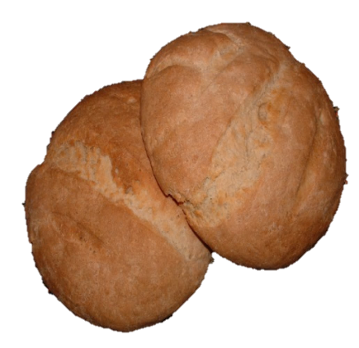**Roman Panis Bread**

**Ingredients:**

* 500g of Flour
* 350ml of Warm Water
* ½ Finely Chopped Onion
* 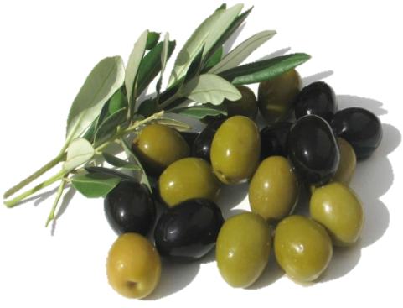1 tbsp. of Active Dried Yeast
* 1 tbsp. of Honey
* 1 tbsp. of Olive Oil
* 1 tsp. of Salt
* Pinch of Rosemary

tsp. = teaspoon

tbsp. = tablespoon

**Method:**

1. Dissolve Honey into the Warm Water and sprinkle the yeast on the top.
2. Mix together with a spoon and leave until frothy.
3. Put the finely chopped onion, flour and salt into a bowl and add the oil and yeast mixture.
4. Knead the mix until smooth and no longer sticky.
5. Split the dough into 3 and knead each piece separately.
6. Allow to prove until the dough has slightly risen.
7. Split the dough into separate rolls.
8. Place on a slightly oiled baking tray and bake in a preheated oven (230 degrees or gas mark 8) for 20-30 minutes.
9. Remove from oven and allow to cool.