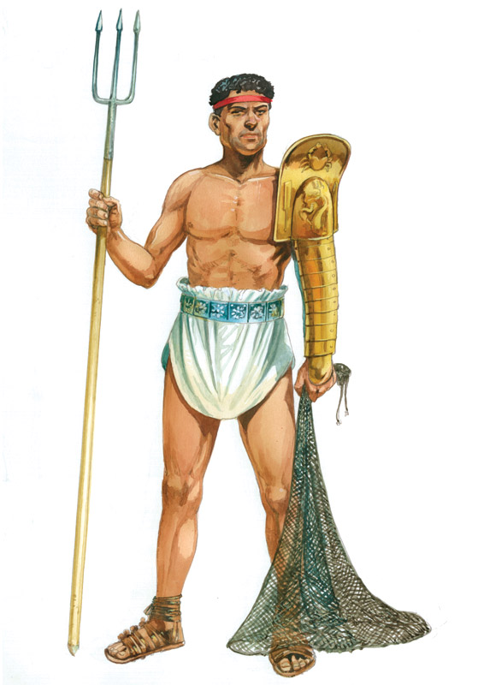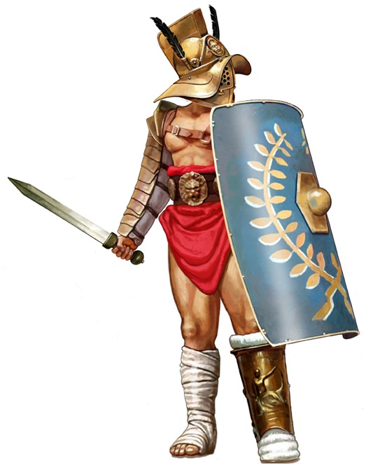

Trident

Sword

Shin armour

Helmet

Shield

Net

Shoulder armour

The Retiarius

The Murmillo