Gods and Gladiators: Homework

Dear Parent/Guardian,
In the space below, encourage your child to fill in the blank spaces with the words from the box below.

Roman soldiers sent letters home to their families to tell them what life was like in Britain. Fill in the blank spaces with words from the box below to make a letter that a Roman could have sent home.
To my ___________
I am now fighting in_______________. It is very ________ here, so could you send me some more ___________. The people who live here are called ___________. I fight them with my ____________ and ____________ . My boss _________________ says we are coming home soon. This makes me_______________ .
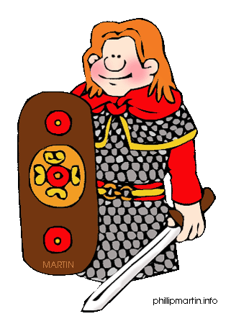
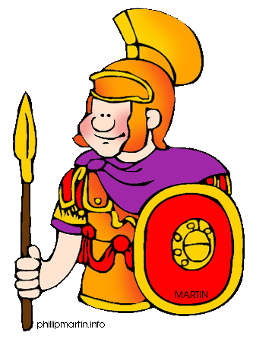
See you soon!
Sword Happy Cold Socks Julius Caesar Celts Family Wales shield

