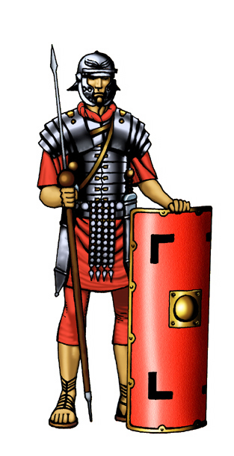 **The Roman Soldier**

**____________**

**____________**

**____________**

**____________**

**____________**

**____________**

**Sword Shield Sandals Helmet Armour Javelin**