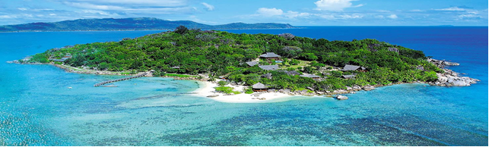**Sailors and Centaurs**

**1) Listen to the story; write number in the order column where the sentence is placed.**

|  |  |
| --- | --- |
| **Order** |  |
|  | Nautae veniebant ad pontem. |
|  | Nautae prudenter ambulabant trans pontem. |
|  | Olim nautae navigabant ad insulam. |
|  | Centauros! |
|  | Centauri oppugnabant nautas sagittis. |
|  | Nautae videbant silvam et ambulabant in silvam. |
|  | et nautae currebant a Centauris. |
|  | Nunc ambulabant super flumen et videbant |

**C:\Users\Callum\AppData\Local\Microsoft\Windows\Temporary Internet Files\Content.IE5\Z8D1Z5AO\MC900149323[1].wmfC:\Users\Callum\AppData\Local\Microsoft\Windows\Temporary Internet Files\Content.IE5\Z8D1Z5AO\MC900149323[1].wmf2) Underline all the verbs you can see in the sentences above, and circle the prepositions.**

**3) Write the story in the correct order and change the verbs into the 1st person singular and the subject into the singular. (Look through your notes to help you remember the singular and plural of nouns!)**

______________________________________________________________________________________________________________________________________________________________________________________________________________________________________________________________________________

**C:\Users\Callum\AppData\Local\Microsoft\Windows\Temporary Internet Files\Content.IE5\RVX2XO86\MC900324452[1].wmfC:\Users\Callum\AppData\Local\Microsoft\Windows\Temporary Internet Files\Content.IE5\RVX2XO86\MC900324452[1].wmf**

C:\Users\Callum\AppData\Local\Microsoft\Windows\Temporary Internet Files\Content.IE5\N3KVTXT9\MC900149323[2].wmfC:\Users\Callum\AppData\Local\Microsoft\Windows\Temporary Internet Files\Content.IE5\N3KVTXT9\MC900149323[2].wmf

C:\Users\Callum\AppData\Local\Microsoft\Windows\Temporary Internet Files\Content.IE5\N3KVTXT9\MC900149323[2].wmfC:\Users\Callum\AppData\Local\Microsoft\Windows\Temporary Internet Files\Content.IE5\N3KVTXT9\MC900149323[2].wmf