Chapter 2: Roman myth
What is a myth? Do you know how it differs from legend?
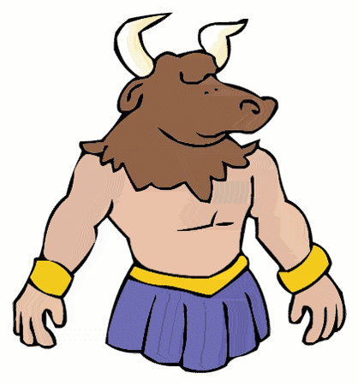
Do you know any Welsh myths? Do you know any Roman myths?
Can you find Greece and Crete on the map of the world?

Acting out: Theseus and the Minotaur
Once upon a time, there was a fortis but horribilis rex called Minos. He was rex of the island Crete and everyone who lived there was timidus of him. But rex Minos had a problem: ‘I am strong, but I am also timidus. I fear the monster that lives in my palace: the Minotaurus. The Minotaurus is half taurus, half man. Therefore I have built a labyrinthus to stop him from escaping.’
His milites said: ‘But how will you stop the Minotaurus? He edit people. How can we be sure that he will stay in the labyrinthus?’
Minos replied: ‘I will tell the urbs of Athens they have to give me seven boys and seven girls every annus. We will shut them up in the labyrinthus until the Minotaurus edit them all.’
And so, each annus the urbs of Athens sent seven boys and seven girls to Crete, so the monstrous Minotaurus edit them. It was a horribilis time, and everyone in the urbs of Athens was very tristis.
One day, a young hero arrived in the urbs of Athens. His name was Theseus and he was very fortis. He saw seven boys and girls being brought to a navis and audit them crying. He interrogat: ‘What is going on?’
The boys and girls said: ‘We are being brought to the Minotaurus. He edit us. Please save us! We are timidus.’
And so Theseus took the place of one of the boys and told the people of Athens: ‘Don’t be tristis. I will return with the children!’
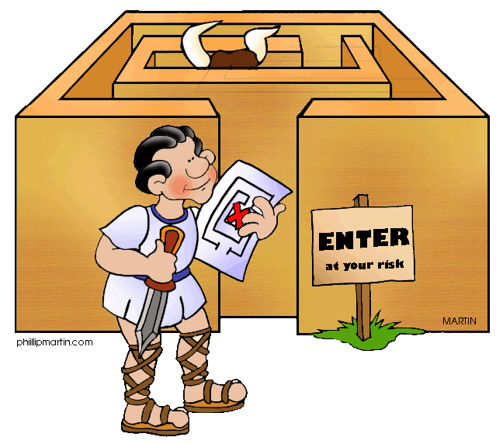
So the navis navigat to Crete, and king Minos was waiting for them when they arrived. He ridet and said: ‘You are so young and bony, you hardly look like a tasty meal for the Minotaurus. Who will go in first?’ They could hear the Minotaurus roaring in the labyrinthus.
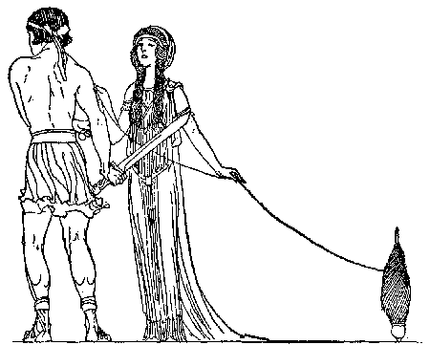
Theseus stepped forward: ‘I will go first. Sum prince Theseus of Athens and I am not timidus of the Minotaurus.’
While Theseus went into the labyrinthus, king Minos watched. Behind him stood his filia, Ariadne. She immediately amat the fortis hero, Theseus, and decided to help him. She whispered as he went in: ‘Theseus, take this corda and tie it to the entrance of the labyrinthus. When you have killed the Minotaurus, this corda will guide you back there.’ He ridet and said: ‘Thank you.’
As Theseus walked into the labyrinthus, he audit lots of animals. First, he thought he audit a leo, then a canis, a serpens, a mus, a gattus, or was that an equus? They all seemed to shout: ‘Don’t go on! Turn back!’ It was pretty scary in the dark, smelly, horribilis labyrinthus. But then audit the worst noise of all: that of a raging taurus!
Suddenly, the Minotaurus roars: ‘I will eat you now, Theseus!’ The hero was picked up between the Minotaur’s horns and tossed into the air, then thrown onto the terra. But Theseus grabbed the Minotaur’s horns and kept twisting his head. Suddenly he tugged it, and the terribilis creature died lying on the terra.
The hero took the corda and was led safely back to the entrance. The milites and the children shouted: ‘Theseus is fortis! You are our hero!’
Ariadne stood there too: ‘Please take me back to Athens with you. Sum timida. My father will kill me when audit that I have helped you.’
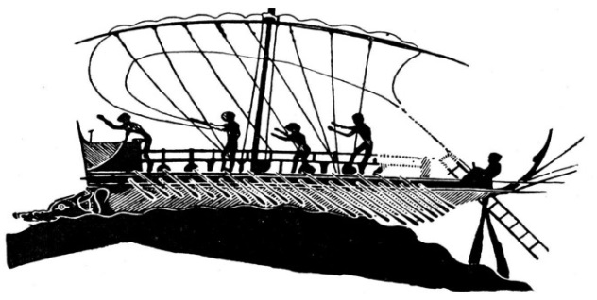
Theseus and the children replied: ‘Of course we will take you!’ And so Theseus navigat with the others to the urbs of Athens. The people from Crete were very happy that the Minotaurus was dead, apart of course from terribilis rex Minos.

Exercise 1: Fill in the gaps with Latin words you think are suitable
- The ____________ was admired and loved by all citizens.
- It is said that the labyrinth was the home of the _______________________.
- The commander ordered the _____________________ to retreat.
- The captain brought the _________________________ inside the port.
- It is said that the mighty Theseus killed the Minotaur in a ______________________.
- It was a _________________________ accident. Many people were injured.
- The brave soldier raised his _________________ to defend himself from the enemy.
- The beautiful _______________________ was captured by the Minotaur.
- The little boy is so _____________________and hides himself inside the closet.
- The prisoner was tied up with a _______________________________.

Exercise 2: Connect the Latin words with their English translation.
Can you give any English words that come from the Latin word?
Can you use the English words in a sentence?
Are the words verbs (V), nouns (N), or adjectives (A)?
Latin word | English translation | Related English word | Verb, noun, or adjective?
Amat
Annus |  | Annual
Audit
Canis | Dog
Corda
Edit
Equus
Filia |  | Filial
Fortis |  |  | A
Gattus
Horribilis
Interrogat
Labyrinthus
Leo
Milites
Minotaurus – Taurus
Mus
Navigat | Navigate |  | V
Navis
Rex
Ridet
Serpens
Sum | I am
Terra |  | Extra-terrestrial
Timidus
Tristis
Urbs |  |  | N

Exercise 3: Make your own myth, using some of the Latin words on the previous page.

Exercise 4: Colour the words in the right colours
This song can be sung to the tune of ‘what does the fox say?’
Noun/adjectives: subject and object
verbs: I (first person = ends on -o) and he (third person = ends on -t)
Rex tristis amat filiam.
Audit me: timidus est.
Navigat Theseus
in terram: firmus est.
Theseus vidit filiam
et filiam amat.
Theseum firmum edo:
SUM MINOTAURUS!

Sum tristis: amo filiam.
Audio te: timidus sum.
Navigo, Theseus,
in Cretam: firmus sum.
Puellam bellam video
et puellam amo.
Minotaurum audio:
TAURUM NECABO!
Sum Minotaurus!
Listen to the song and fill in the gaps.
Rex tristis amat filiam. Audit ___________: timidus est.
Navigat Theseus in terram: firmus _____________.

Theseus vidit filiam et _________________ amat.
___________ firmum edo: SUM MINOTAURUS!

Sum __________: amo filiam. _________ te: timidus sum.
Navigo, Theseus, in Cretam: _________________ sum.

Puellam bellam video et ______________ amo.
Minotaurum ____________: TAURUM NECABO!

Link the Latin word with an English word that is based on the Latin.

Latin word English word from Latin Meaning of Latin word
timidus firm I hear
navigat audio-visual I love
terram navy He sails
firmus amorous afraid
vidit timid I eat
amo edible strong
edo extra-terrestrial land, earth
audio view He sees

