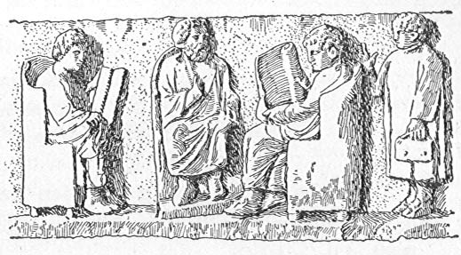
Make your own story about your day as a Roman familia
Each character can talk about their day and you can talk about things you have done together.

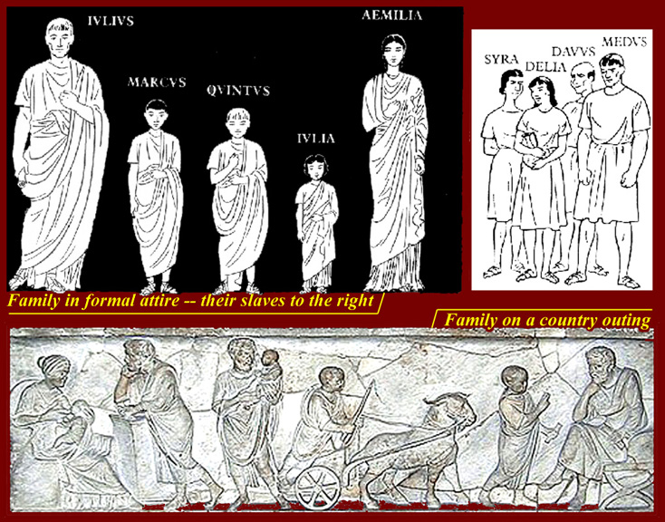

Some words to help you
Verbs
Amo – I love
Verbs
Am(a)-o I love
Ama-s you love
Ama-t he/she/it loves
Ama-mus we love
Ama-tis you love (many)
Ama-nt they love
Ambulo – I walk
Celo – I hide
Curro – I run
Disco – I learn
Edo – I eat
Emo – I buy
Facio – I make
Instruo – I teach
Laboro – I work
Narro – I tell
Paro – I prepare
Rogo – I ask
Specto – I see
Sum – I am (es = you are; est = he/she/it is)
Coquo – I cook
Vendo – I sell
Nouns
Subject Object
Amic-us Amic-um
Fabul-a Fabul-am
Ager Agr-um
Nouns
Ager – field
Amicus/amica – Friend
Cibus – Food
Dea/Deus – Goddess/god
Domus – house
Fabula – Story
Luna – Moon
Mensa – Table
Nauta – Sailor
Taberna –Shop
Via – Road
Villa – House

Some extras
ad: to/towards/onto
iratus: angry
laetus: happy
tristis: sad

Extra work – homework

- You can see one Latin word and different English words. Can you spot which English words come from the Latin? Connect the English words with the Latin words with a line. We’ve already done one for you.

Fake
Factory Face
Facio
Favour

- Let’s try another one:

Prepare Parrot
Separate
Paro
Appear
Compact

Can you make a sentence with the word separate? Make it as silly as you like.

________________________________________________________________

- YOU NEED TO ASK YOUR PARENTS TO HELP YOU WITH THIS. Go to www.zondle.com (you have to create a username and password) and type in ‘Latin familia’ in the search terms. We have created two games for the pupils to play to memorise the words they are learning.

- What do you think is the biggest difference between modern and Roman families? Write about it here:
____________________________________________________

____________________________________________________

____________________________________________________

