Making Roman pots
Romans made pots by moulding clay. They could be used to store food and drinks, and some were decorated with pictures to tell stories.

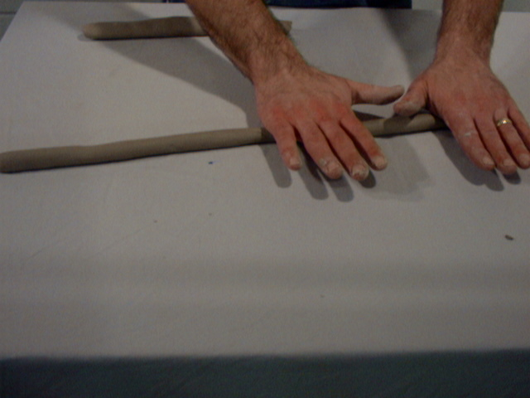
- Take about ¾ of your ball of clay and roll it on the table with your hands to make a long line, about the thickness of your finger.

- Make the other part of clay into a flat circle
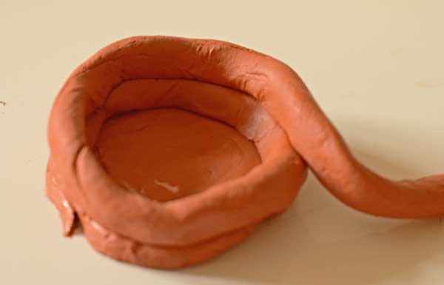
- Putting one end of the long piece of clay onto the edge of the circle, spiral it around the edge. Spiral it on top of the other clay to build it upwards.

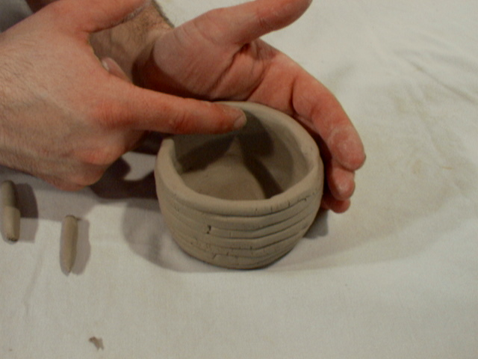
- Smooth the sides of the pot with your fingers

- Draw on the clay with a pencil to decorate your pot!

