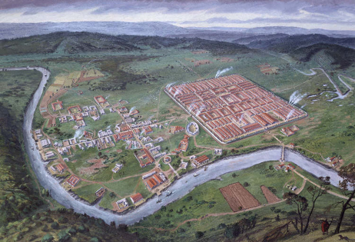

Barracks
General’s quarters
Town houses
Theatre
Defense Wall

