Latin | Picture |  | English word |  | Meaning
FEMINA | 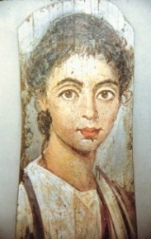 |  | FEMALE |  | WOMAN
POETA |  |  | POETRY |  | POET
AGRICOLA | 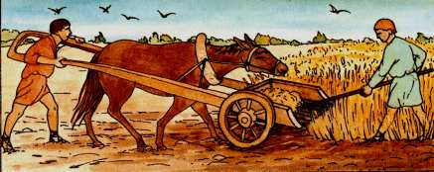 |  | AGRICULTURE |  | FARMER
AQUA | 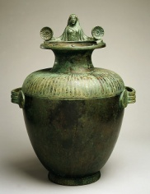 |  | AQUARIUM |  | WATER
MAXIMUS | 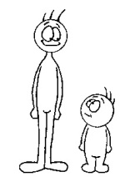 |  | MAXIMUM |  | MOST
FRIGIDUS |  |  | FRIDGE |  | COLD
TERRA | 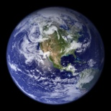 |  | TERRACE |  | EARTH
AUDIO |  |  | AUDIENCE |  | I HEAR
ALIUS |  |  | ALIEN |  | OTHER
Latin | Picture |  | English word |  | Meaning
FEMINA
POETA
AGRICOLA
AQUA
MAXIMUS
FRIGIDUS
TERRA
AUDIO
ALIUS
FEMALE |  | WOMAN
POETRY |  | POET
AGRICULTURE |  | FARMER
AQUARIUM |  | WATER
MAXIMUM |  | MOST
FRIDGE |  | COLD
TERRACE |  | EARTH
AUDIENCE |  | I HEAR
ALIEN |  | OTHER

