Roman Mater
This is Agrippina. She is married to a senator and lives a very wealthy lifestyle.
Being a mater is dangerous in Rome, as there is not much medical help for giving birth. Women give birth on a birthing chair with the help of a midwife. Sometimes a medicus is present but not always.
Agrippina has four pueros, three filios et one filiam. She has tres servos et unum coquum to help look after the domum.
While her maritus is working, it is her duty to give her servos their orders, such as cleaning duties and looking after the pueros. She is also responsible for the education of the children: she selects the magistrum and the pueri are educated at home.
Roman matres have to be elegantes, fidae, and respectful. During the evening, when the children are in bed, Agrippina likes to go to the Roman balneas, attend dinner parties with her husband and go to the tabernas.

Can you answer these questions?
Why is it danger to be a mother in ancient Rome?
_______________________________________________________________________

_______________________________________________________________________

If Agrippina only had one son, what ending would you need for fili__________?

If Agrippina had more than one cook what ending would you need for coqu________?
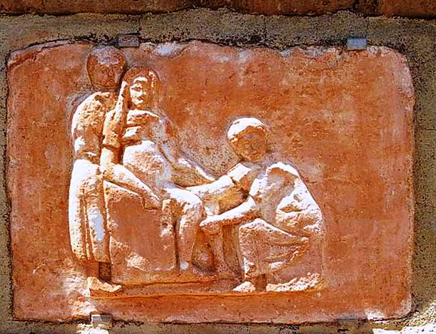
What is the Latin plural form of shop? ________________________________________
How is the mother responsible for the education of her children?
_____________________________________

_____________________________________

_____________________________________

What do Roman women do in the evening?

___________________________________________________________________________

How do you think Agrippina’s life differs from the lives of poor mothers?

___________________________________________________________________________

Can you connect the Latin words with the correct translations?
Elegans faithful
Fida bath
Balnea elegant
Medicus doctor

