The Myth of Deucalion and Pyrrha
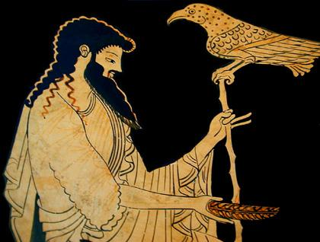
DEUCALION and PYRRHA were ὁ πρῶτος βασιλευς and βασιλεια of Northern Greece. Deucalion was the son of Prometheus, the creator of ανδρες, while Pyrrha was the daughter of Pandora, ἡ first γυνη.

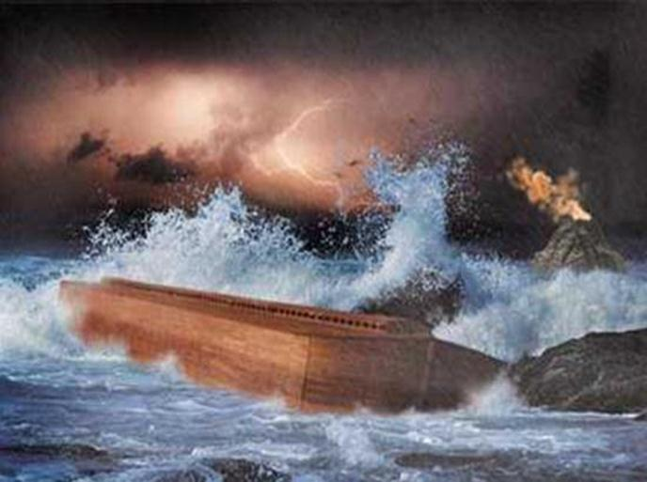
They were born in the time of ὀ Bronze γενος of ανδρες, a warlike race who succeeded the Silver and the Gold. Of these the Bronze was ὁ πρῶτος naturally born generation, and ὁ πρῶτος to include both ανδρες and γυναι. ὁ πρῶτος γενος, the Golden, had been moulded of γη in the time of Kronos, and passed away without producing any issue. ὁ second γενος, the Silver, was created by Prometheus during ἡ αρχη of Zeus, and marrying the Melian nymphs sired ὁ Bronze γενος.

The Bronze generation, however, was very corrupt. Zeus was angered by their impiety and sent a Great Deluge to the envelop ἡ γη and destroy them. Only Deucalion and Pyrrha survived--having been warned of the impending disaster by Prometheus, they mounted ναυς and sailed to the dry peaks of Mount Parnassos. Other Greek regions also claimed survivors-- βασιλευς Dardanos was said to have sought refuge on Mount Ida in the Troad, Kerambos was carried to the heights of Mount Othrys by the Nymphs, Megaros fled to Mount Gerana, Arkas and Nyktimos were preserved on Mount Kyllene in Arkadia, and οἱ δεμοι of Parnassos fled to the heights above Delphoi. Io and her son Epaphos, who lived in Egypt, were also preserved.

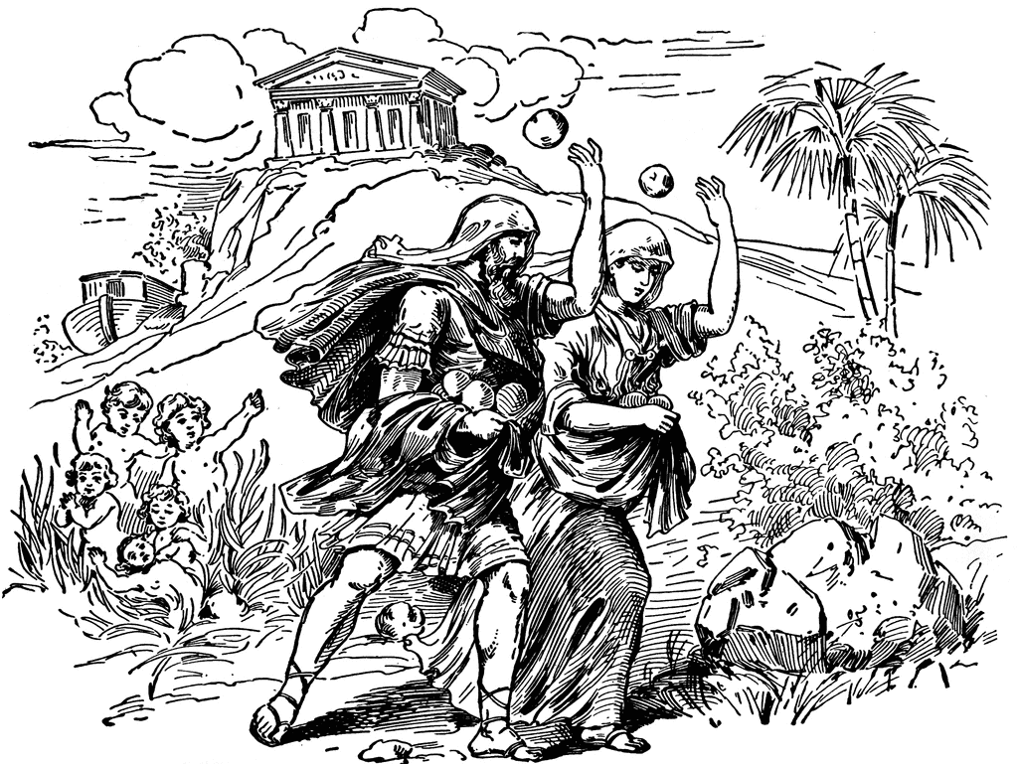
Zeus then caused ἡ θαλασσα to recede. In Northern Greece Poseidon split the mountains at the Vale of Tempe to release αἱ θαλασσαι trapped in the Great Thessalian Plain. Deucalion and Pyrrha then consulted the Delphic oracle to ask how they might repopulate ἡ γη and were told to cast the bones of their mother over their shoulders. They answered this riddle by casting oἱ λιθοι --the bones of Mother Earth--one producing a tribe of ανδρες and the other of γυναι.

Deucalion had several sons and daughters. The most famous of these were Hellen, ὁ βασιλευς of the Hellenes (i.e. Greeks), and Pandora. Deucalion's descendants were rulers of most of the kingdoms of mythical Greece.

Vocabulary for the Myth of Deucalion and Pyrrha

θαλασσα | ‘tha-la-sa’ | sea
δεμος | ‘dem-os’ | people
ανδρες | ‘and-res’ | men
γυνη | ‘gun-e’ | women
λιθος | ‘lith-os’ | stone
γη | ‘ge’ | earth
βασιλευς | ‘bas-i-le-us’ | king
βασιλεια | ‘bas-i-le-a’ | queen
γενος | ‘gen-os’ | race
ναυς | ‘na-us’ | ship
αρχη | ‘arch-e’ | reign
πρῶτος | ‘prot-os’ | first

