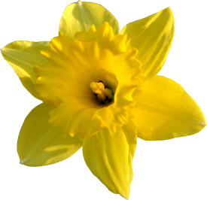
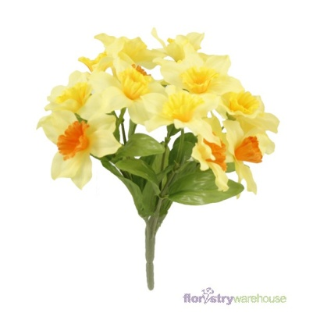
Narcissus

Ἠχω is a beautiful νυμφη. Ἡρα is jealous and curses her saying: ‘μισω you, from now on οὐκ ἐχεις your own words!’.
Ναρκισσος is a handsome boy. Everybody loves him, but φιλει nobody.

One day Ἠχω sees Ναρκισσον in the forest. κρυπτει but he notices someone is following and καλει: ‘Is anyone here?’
‘Here!’ λεγει, and she runs to him to kiss him.
Ναρκισσος is shocked and rejects her. λεγει: ‘I will not let you love με’.
Ἠχω ἀκουει and λεγει: ‘Love με!’
Embarrassed, Ἠχω runs away to a nearby cave. Her body wastes away from grief, but her voice μενει there as an ἠχω.

Ναρκισσος rejects many other nymphs too. They are upset and pray: ‘We hope Ναρκισσος φιλει someone but οὐκ ἐχει love him in return’. Their wish is granted.
One day, Ναρκισσος is tired from hunting in the forest all day. παυει and drinks from a beautiful pool of water.

Suddenly he sees a beautiful vision, and instantly falls in love. λεγει: ‘φιλω you. φιλεις με?’ He smiles, and the vision smiles back. He reaches out, and the vision reaches back. However the vision disappears as the water κινει, and he can’t reach his love. For φιλει his own reflection.
He suffers terribly and λεγει: ‘I don’t eat. οὐ πινω. Why κρυπτεις?’
Ναρκισσος wastes away at the pool and παυει being able to live. All the nymphs weep, and Ἠχω repeats their cries.

A daffodil grows where his body used to be, leaning over the pool just like Ναρκισσος.

Some vocabulary

hate = μισω have = ἐχω
love = φιλω hide = κρυπτω
call = καλεω say = λεγω
hear = ἀκουω remain = μενω
stop = παυω drink = πινω
move = κινω eat = ἐσθιω

