Negative
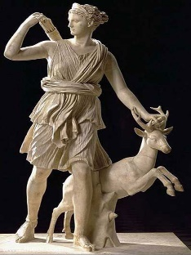
The normal negative is οὐ. This changes (to help pronunciation) to οὐκ if the next word starts with a vowel with a smooth breathing, and to οὐχ if the next word starts with a vowel with rough breathing. The negative normally comes just before the verb.
1 ὁ στρατηγος βουλην οὐκ ἐχει. _________________________________
2 ὁ θεος την τιμην ἐχει. _________________________________
3 ὁ στρατος οὐκ ἀκουει την ϕωνην. _________________________________
4 ὁ ἀγγελος διωκει την θεαν. __________________________________
5 ὁ ξενος ϕερει την ἐπιστολην. __________________________________
6 την θεαν ϕυλασσεις. __________________________________
7 την εἰρηνην οὐκ ἐχετε. __________________________________
8 συμμαχον οὐκ ἐχετε. ___________________________________
9 ὁ διδασκαλος λογον οὐ λεγει. ____________________________________
10 ὁ θεος την νικην ϕερει. _____________________________________

Greek often uses the definite article for general or abstract qualities, whereas English would not use the.
Prepositions –
Prepositions indicating motion towards take the accusative, as in Latin. Two common ones are:
προς toward
εἰς into
1 την ἐπιστολην προς την κωμην ϕερω _________________________________
2 ὁ θεος προς τόv ποταμον βαινει _________________________________
3 την θεαν προς τήν λίμνη ἀγω _________________________________
4 ὁ δουλος εἰς τον ποταμον τρεχει _________________________________
5 τον στρατον εἰς την ἀγοραν βαινω _________________________________

