Nero and Rome
One night in July Rome was hit by a terrible fire. The fire started in the merchant area of the city and was fanned by summer winds until most of the city was on fire. The fire raged for six days and seven nights. The people tried to stop the spread of the fire; they would run out of their houses hoping to stop the blaze or would run inside and try and stop the spread in there.
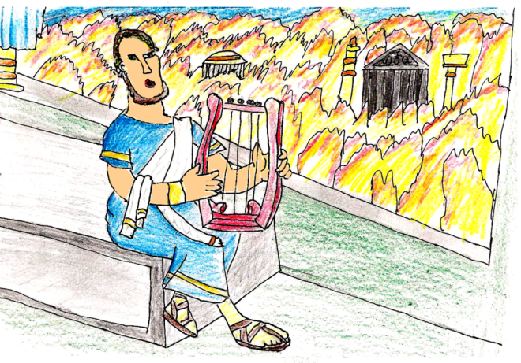
Nero was Emperor of Rome at the time, but had been staying at a palace outside of Rome. He returned to Rome after the fire had started and opened lots of public places, such as the field of Mars and his own gardens for the now homeless people of Rome to shelter in.
In the middle of the huge fire, Nero went up to the roof of the palace and began to sing a song called “The Taking of Troy” but the people believed that he was singing a song about burning Rome. Many people believed that Nero had sent men out into the city to set the first fires so that he could build a new city and name it after him.
More than 70 percent of the city burned over the course of the fire and from the ashes a more spectacular city was built from marble and stone - unlike the old one that had been made of wood. The new city had much wider streets and ample supplies of water in case fires in the future.
Questions
How many days and nights did the fire last?
________________________________________________________________
What was the new Rome built of?
________________________________________________________________
What was the name of the song Nero sang?
________________________________________________________________

