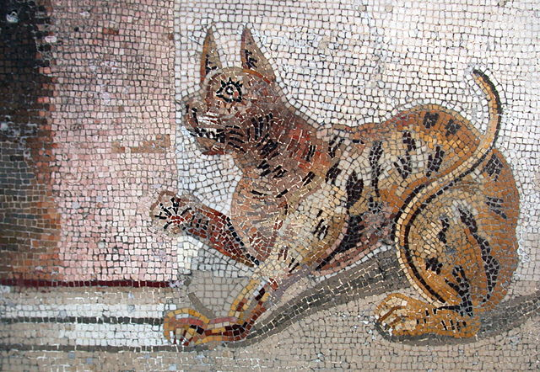
Nouns

SUBJECT
ends in –us or -i

DIRECT OBJECT
ends in –um or –os
Nouns are split into groups called declensions.
We already know about 1st declension nouns – look at your sheet like this with words like agricola (farmer) and nauta (sailor) on it.

The new nouns on this sheet are from the 2nd declension.
Here is how amicus (friend) changes ending –
If it is the SUBJECT of a sentence,
ONE FRIEND = AMICUS
LOTS OF FRIENDS = AMICI
If it is the DIRECT OBJECT of a sentence,
ONE FRIEND = AMICUM
LOTS OF FRIENDS = AMICOS

Amicus | Friend
Avus | Grandfather
Capillus | Hair
Cibus | Food
Coquus | Cook
Deus | God
Dominus | Master
Equus | Horse
Gattus | Cat
Gladius | Sword
Hortus | Garden
Inferus | A dead person
Lupus | Wolf
Oculus | Eye
Porcus | Pig
Servus | Slave
