Nouns

SUBJECT
ends in –a or -ae

DIRECT OBJECT
ends in –am or –as

Agricola | Farmer
Aqua | Water
Barba | Beard
Cena | Dinner
Dea | Goddess
Fabula | Story
Femina | Woman
Insula | Island
Luna | Moon
Nauta | Sailor
Poeta | Poet
Puella | Girl
Regina | Queen
Toga | Toga
Via | Street
Victoria | Victory
Villa | House
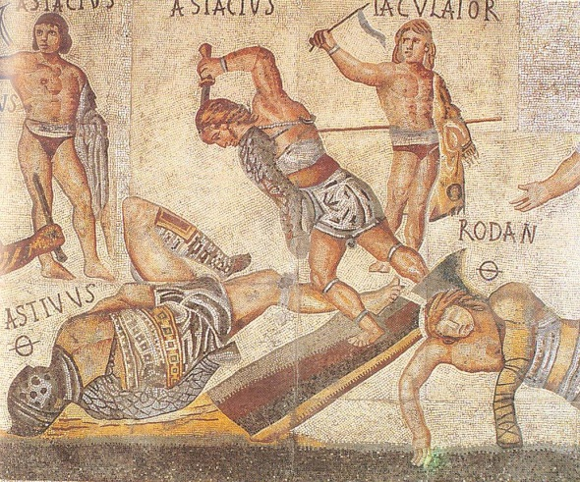
Verbs
amo = I love
amas = you love
amat = he/she/it loves
amamus = we love
amatis = you love
amant = they love

Adiuvo | I help
Aedifico | I build
Ambulo | I walk
Amo | I love
Canto | I sing
Ceno | I eat
Circumspecto | I look around
Do | I give
Exspecto | I wait for
Habito | I live
Impero | I command
Laboro | I work
Narro | I tell/narrate
Neco | I kill
Oppugno | I attack
Paro | I prepare
Rogo | I ask
Specto | I watch
Voco | I call
